Name:________________________________________________________ Date:___________________ Period:_______
ARE YOU LIGHTEST IN THE MORNING?
Claim: You are heaviest at night before you go to bed, and lightest in the morning when you wake up.
Evidence: You don’t eat anything while you are sleeping and yet you are still burning calories. I have also weighed myself at night and in the morning and have seen a loss in weight overnight and not because I used the toilet.
- Evaluate this argument – is the evidence sufficient? Why or why not?

- Why do YOU think a person could be heaviest before bed but lightest when they wake up? How do you lose weight while you’re sleeping (where does the mass go)?

Use the information provided to answer the following questions. BE SURE TO LABEL WITH CORRECT UNITS!
- In Derek’s experiment he is losing approximately 250 grams (g) of mass every night.
- Let’s assume that you sleep about 8 hours a night. Let’s also assume that you take about 16 breaths per minute.
- In an average breath you inhale about 500 mL of air.
- About 21% of that air is made up of oxygen (O₂).
- Not all the oxygen in the air is absorbed by the lungs. When you exhale, the majority of the oxygen you breathed in is just breathed out again.
- About 22% of the oxygen you inhaled is replaced with carbon dioxide (CO₂) from the lungs.
- The total carbon exhaled in a single breath is about 0.012 g.
- One pound (lb) equals 453.6 g.

- What volume of oxygen (O₂) is inhaled in an average breath of air? _________________

- What volume of carbon dioxide (CO₂) is exhaled with every breath? _________________

- Looking at the chemical formula of atmospheric oxygen and carbon dioxide, what is the difference between these molecules? _________________________________________________________________________

- How many grams of extra mass do you exhale in a single breath? _________________

- How many grams of mass do you exhale in one night’s sleep? ________________ In pounds? _______________

- Derek supposes that whatever mass is not lost as carbon dioxide is lost as water via sweat and water vapor in our breath. About how many grams of water do you lose each night? ___________________
- What is the formula for cellular respiration? ____________________________________________________

- This video exploration is a lesson in the Law of Conservation of Matter. In your own words describe what this law means:

- Methane (CH₄) is the main component of natural gas and the second most prevalent greenhouse gas emitted by the U.S. Using what you know about the Law of Conservation of Matter try to balance this formula for the combustion of methane gas:

____ CH₄ + ____ O₂ + spark ____ CO₂ + ____ H₂O + energy

- How are combusting natural gas and cellular respiration similar?

- What molecule can be used by cells to obtain energy? _______________

- Which organelle is responsible for converting sugars and other macromolecules into this molecule? _________________________
Okay, so you’re almost done with this assignment and you’re probably thinking you’re pretty smart. Here’s one more question, just to make sure
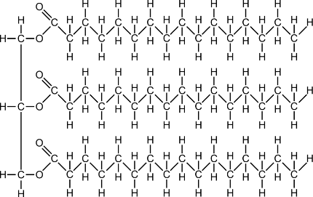
The basic chemical structure of fat
Have you ever seen those weight loss ads with the “Before & After” photos? Or have you ever exercised to shed a few extra pounds? When you burn fat, where does it go? It doesn’t just disappear…does it? About a year ago, experts in fat loss (doctors, dieticians and physical trainers) were surveyed for the answer to the question “When you burn fat, where does it go?” None of the participants knew the correct answer although they thought they did. More than 50% said that the fat is converted into energy and lost as heat. That can’t be right…
- After your glucose reserves have been used up (for example, due to exercise) your body uses fat as its fuel for cellular respiration. Show off your knowledge of respiration to explain where fat goes when you “burn it off”.

