CHI-SQUARE PRACTICE PROBLEMS
For each of the following problems determine 1) the null hypothesis, 2) the Chi Square value and use the appropriate critical value to then 3) accept or reject the null hypothesis. Use the table of critical values below.
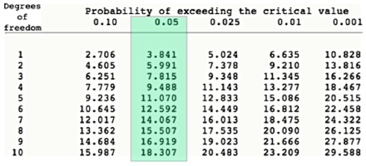

- A poker-dealing machine is supposed to deal cards at random, as if from an infinite deck. In a test, you counted 1600 cards, and observed the following:

Spades 404
Hearts 420
Diamonds 400
Clubs 376
Is the machine equally likely to deal a card of any of the four suits?
- A genetics engineer was attempting to cross a tiger and a cheetah (It’s a Chester Cheeger!). She predicted a phenotypic outcome of the traits she was observing to be in the following ratio:

4 stripes only: 3 spots only: 9 both stripes and spots.

When the cross was performed and she counted the individuals she found 50 with stripes only, 41 with spots only and 85 with both. According to the Chi-square test, did she get the expected outcome?

- In the garden pea, yellow cotyledon color is dominant to green, and inflated pod shape is dominant to the constricted form. Considering both of these traits in self-fertilized dihybrids, the progeny appeared in the following numbers:

193 green, inflated
184 yellow constricted
556 yellow, inflated
61 green, constricted

Do these genes assort independently?

