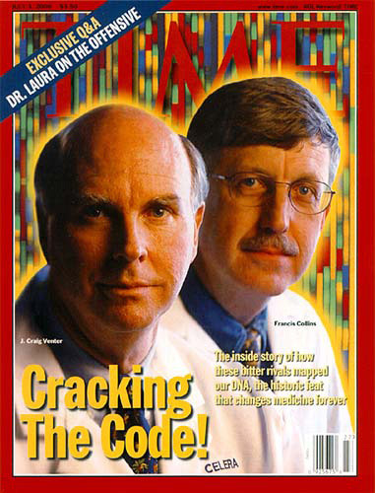
Name ______________________________ Period ____________
Cracking the Code
Directions: Watch the episode at the link below. The numbers on the left hand side tell you approximately where the answers can be found (4:35 means 4 minutes, 35 seconds into the program).
http://www.pbs.org/wgbh/nova/body/cracking-the-code-of-life.html

- (4:35) The message of life has been passed down from one generation to the next in what form?

- What does DNA look like (either from the lab or from the video)?

- How many more genes do humans have than fruit flies?

- (10:50) How closely are you related to the person sitting next to you? (In a percentage form)

- In the past, how long did it take to find particular gene?

- What % of our genes are used to code for proteins?

- Now, how fast do we “get the letters” out (find the code for DNA).

- (16:00) A person with Tay-Sachs Disease has one letter (or base) changed in their DNA. What are the effects of this one mutation? Write your answer in at least 2 complete sentences.

- What is a mutation? (From your notes).

- (25:00) – What is the ultimate hope or goal of coding the entire genome?

- (41:00) – Again, how closely are we are related on a genetic level?

- Why are we so closely related?

- What is the one thing we have learned today about the DNA code?

