Name:____________________________________________ Date:___________________ Period:__________

D.E.A.R. REVIEW

Directions:
- Read the passages about characteristics of living things.
- Read the passages a second time – this time highlight main ideas and circle key words.
- Fill in the blank next to each letter to describe which characteristic it represents.

D - _______________________________ E - ____________________________
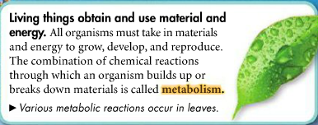
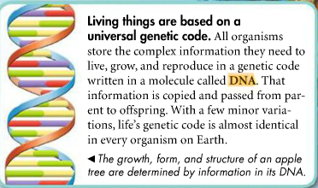

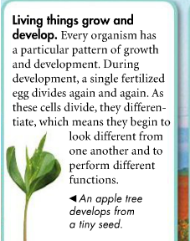

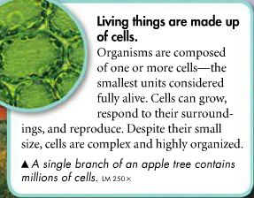

R - _______________________________ A - ____________________________
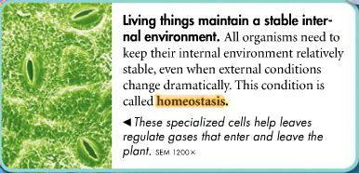
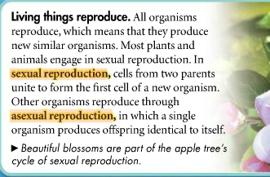

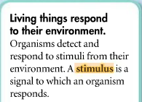
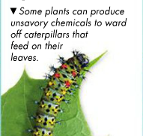

Directions: Use the graphic organizer to summarize what you read on the previous page. Title each box with one of the four characteristics of living things and draw 2-3 pictures about that characteristic.
Characteristics of Living Things

Teresa has found a strange object in her backyard. It is small, blue and round. She wants to determine if it is living or not so she performs several tests.
- Teresa placed the blue object in a small dish of water. A couple days later she noticed the object had sprouted some kind of tendril.
- Teresa placed the blue object in a sunny window. A week later the object had doubled in size.
- Teresa took the temperature of the blue object. It was 18 °C. She placed it in a cooler of ice for one hour and took the object’s temperature again. She recorded it to be 17.5 °C.
Is this object a living organism? Use evidence from Teresa’s tests to show which traits of living things the object does or does not have. Remember: CER!

