Name:____________________________________________ Date:___________________ Period:__________
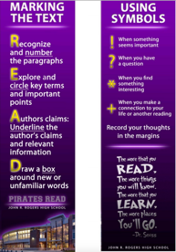
D.E.A.R. REVIEW

Directions: (8 pts)
- Read the passages about characteristics of living things.
- Read the passages a second time – this time use your reading strategies to mark the text.
- Fill in the blank next to each letter to describe which characteristic it represents.

D - _______________________________ E - ____________________________
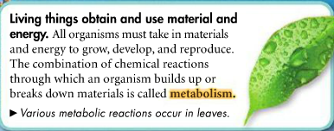
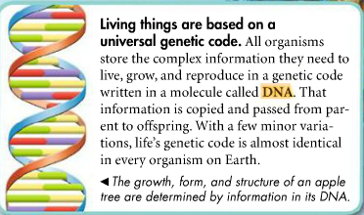

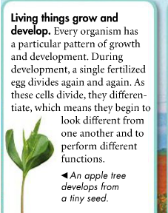

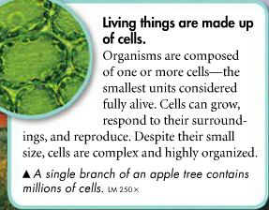

R - _______________________________ A - ____________________________
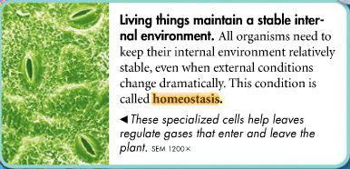
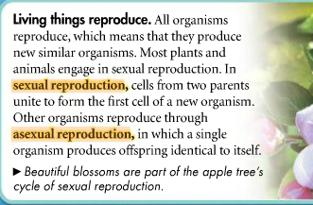

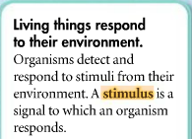
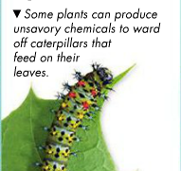

Directions: Use the graphic organizer to summarize what you read on the previous page. Title each box with one of the four characteristics of living things and draw 2-3 pictures about that characteristic. (8 pts)
Characteristics of Living Things

Teresa has found a strange object in her backyard. It is small, blue and round. She wants to determine if it is living or not so she performs several tests.
- Teresa placed the blue object in a small dish of water. A couple days later she noticed the object had a small bulge coming from it.
- Teresa placed the blue object in a sunny window. A week later the object had doubled in size.
- Teresa took the temperature of the blue object at 18 °C. She placed it in a cooler of ice for one hour and took the object’s temperature again. She recorded that the object’s temperature was 17.9 °C.
Is this object a living organism? Complete the sentence templates below to construct an argument to support your answer. You can use a separate sheet of paper if you need additional room to write. (3 pts)

- My claim is that the object is living / non-living. (circle one)

- (Claim) __________________________________________________ because (evidence) ___________ ___________________________________________________________________________________.

- (Claim) __________________________________________________ but (evidence) _______________ ___________________________________________________________________________________.

- (Claim) __________________________________________________ so (reasoning) _______________ ___________________________________________________________________________________.

