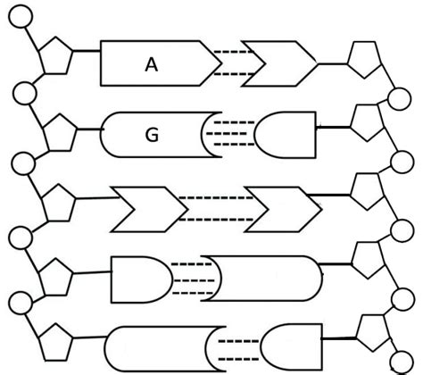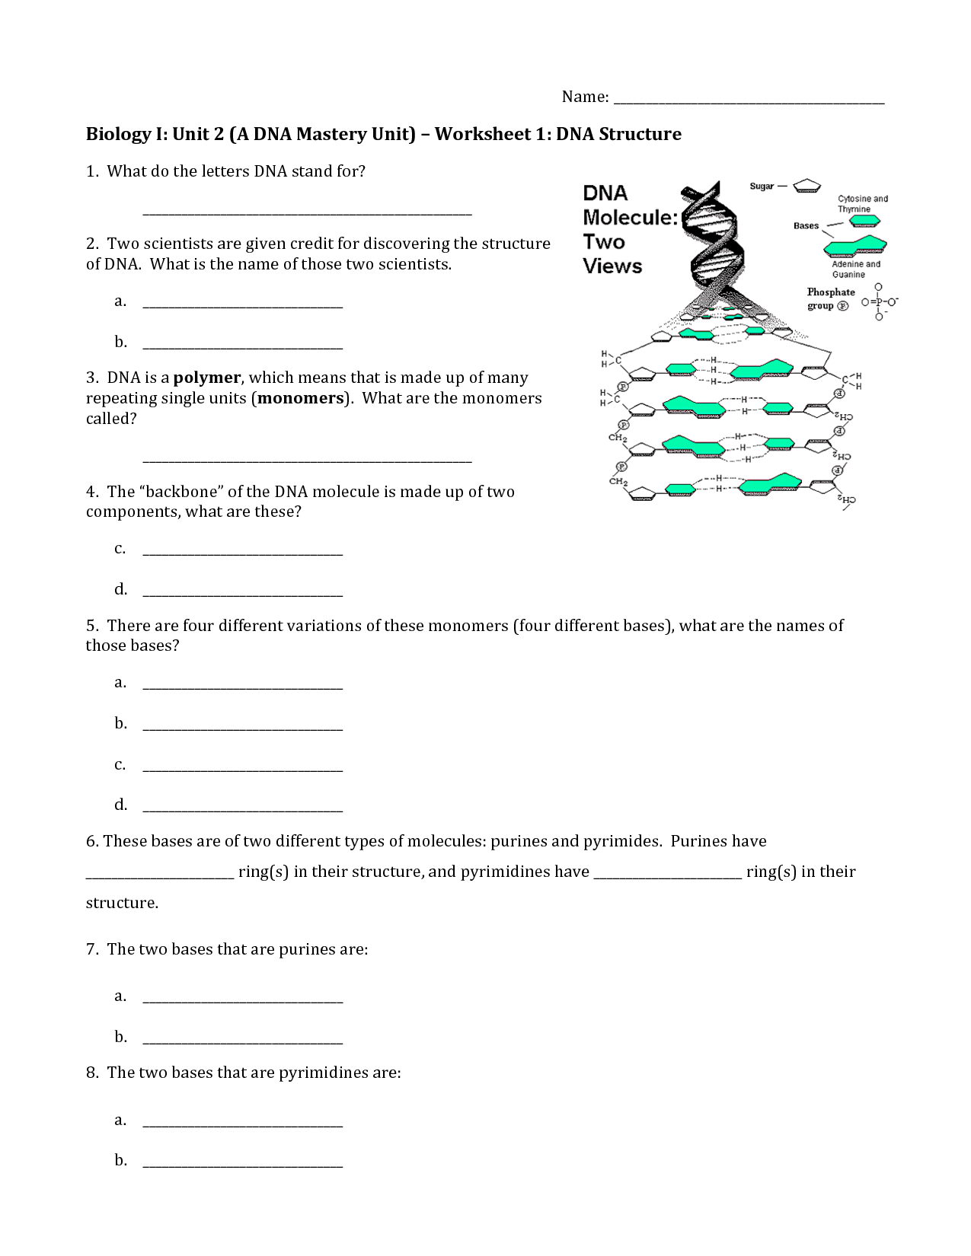

Phosphates = orange

Deoxyribose sugar = purple

Adenine = red

Guanine = green

Cytosine = blue

Thymine = yellow

6. Complete the diagram of a DNA molecule by filling in the appropriate base letter, according to the DNA base pairing rules. Then color the diagram according to the legend below.

2. a) What group of macromolecules does DNA belong to?

b) What is another example of a molecule in this group?