Enzyme Practice Worksheet

Name ____________________________________ Date _____________ Period _____

Directions: Examine the model of the enzyme reaction. Answer the questions that follow.

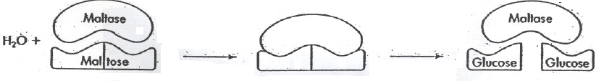

- What is the name of the enzyme shown in this model?

- What is the name of the substrate shown?

- Does the reaction represent dehydration synthesis or hydrolysis? Explain.

- How are enzymes named?

- To what class of biological compounds do enzymes belong?

- Explain how enzymes affect activation energy and reaction temperature.

- How does the modern induced fit model of enzyme-substrate interaction differ from the, Original lock-and-key hypothesis?

Factors Affecting Enzyme Action

Enzymes work best under certain conditions. Using the data in the chart on the next page to plot a graph showing the rate of enzyme action for the enzymes Pepsin and Trypsin at different varying pH.

pH | Rate of Enzyme  Action (for Pepsin) | Rate of Enzyme  Action (for Trypsin)
1 | 1 | 0
2 | 3 | 0
3 | 7 | 0
4 | 3 | 0
5 | 1 | 1
6 | 0 | 3
7 | 0 | 7
8 | 0 | 9
9 | 0 | 7
10 | 0 | 3
11 | 0 | 1
12 | 0 | 0
13 | 0 | 0
14 | 0 | 0

- Considering the range of pH that it is most effective, where in the body might Pepsin be found?

- At what pH is Trypsin most effective?

- Temperature is also an important influence on enzyme action. At what temperature do you think most human enzymes work best?

- Sketch a graph of what you think the rate of enzyme action would look like between 0 and 100ºC.

Enzyme Rate

0 100
Temperature ºC

- Can you think of any part of the body where an enzyme might work at a slightly different temperature?

