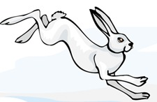
Genetic Crosses that Involve 2 Traits
In rabbits, grey hair is dominant to white hair.
Also in rabbits, black eyes are dominant to red eyes.
GG = gray hair BB = black eyes
Gg = gray hair Bb = black eyes
gg = white hair bb = red eyes
1. What are the phenotypes (descriptions) of rabbits that have the following genotypes:
Ggbb ____________________ ggBB ________________________
ggbb ____________________ GgBb _________________________
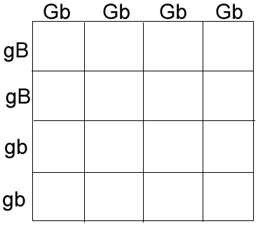 | How many out of 16 have grey fur and black eyes? ______  How many out of 16 have grey fur and red eyes? ________  How many out of 16 have white fur and black eyes? ______  How many out of 16 have white fur and red eyes? _______
2. A male rabbit with the genotype GGbb is crossed with a female rabbit with the genotype ggBb The square is set up below. Fill it out and determine the phenotypes and proportions in the offspring.
3. A male rabbit has the genotype GgBb. Determine the gametes produced by this rabbit
(the sperm would have these combinations of alleles) Hint there are 4 combinations.

4. Use the gametes from #3 to set up a Punnett square on a separate sheet of paper. Put the male's gametes on the top and the female's gametes down the side. Assume the female has the same genotype. Then fill out the square and determine what kind of offspring would be produced from this cross and in what proportion. Use the back of this page for more room.

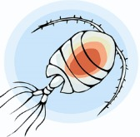
5. An aquatic arthropod called a Cyclops has antennae that are either smooth or barbed. The allele for barbs is dominant. In the same organism, resistance to pesticides is a recessive trait. Make a "key" to show all the possible genotypes (and phenotypes) of this organism. Use the rabbit key (just prior to Question 1) as an example.
6. A Cyclops that is resistant to pesticides and has smooth antennae is crossed with one that is heterozygous for both traits. Show the genotypes of the parents.
______________ x _______________
7. Set up a Punnett square for the cross and show the phenotypic ratios.

