GO GO STEM CELLS

Teach.Genetics.utah.edu
GENETIC SCIENCE LEARNING CENTER
An Introduction to the Stem Cell Niche
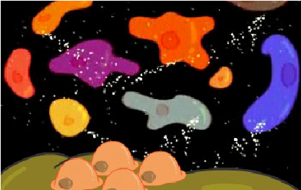 | What is a stem cell niche?
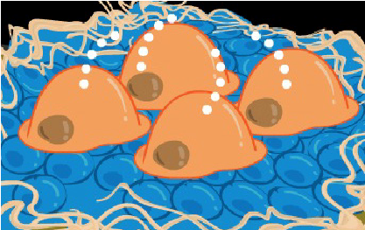 | How does the niche control stem cell differentiation?
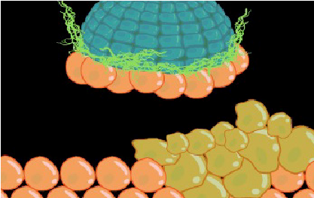 | What can happen if the niche doesn’t function properly?
Brain Cell Niche
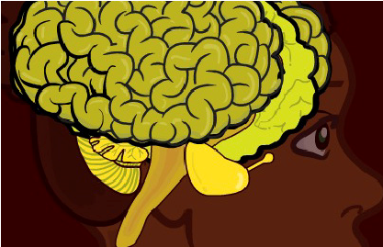 | What two types of cells did the stem cells differentiate into?
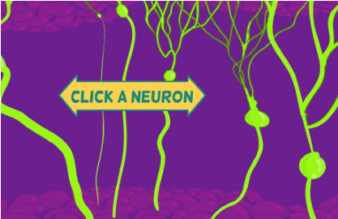 | What are functions of the newly differentiated cells?
Blood Cell Niche
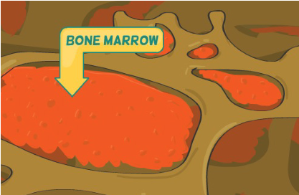 | Newly differentiated red blood cells from this niche produce hemoglobin.  What is hemoglobin?
 | How long will the red blood cell live in the bloodstream before a new one takes its place?
© 2011 University of Utah 1
GO GO STEM CELLS

Teach.Genetics.utah.edu
GENETIC SCIENCE LEARNING CENTER
Hair Follicle Cell Niche
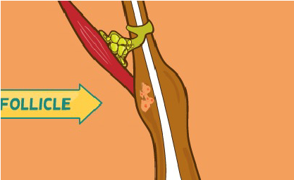 | What type of cell did the stem cell differentiate into?
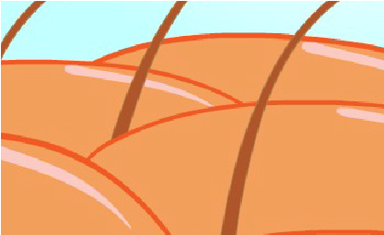 | What other types of cells can stem cells from this niche become?
Bone Cell Niche
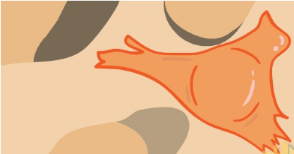 | When do stem cells in this niche receive a lot of signals?
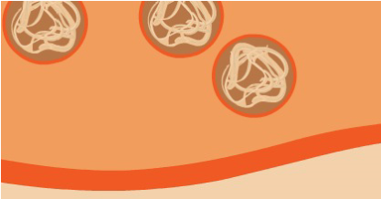 | How do osteoblasts from this niche build and repair bones?
Intestinal Cell Niche
 | 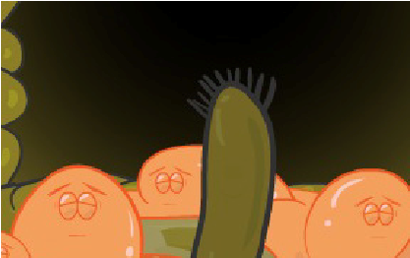 | What type of cell did the stem cell differentiate into?
 | 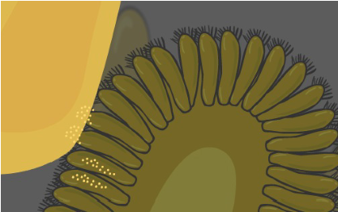 | What is the function of the newly differentiated cell?
FUNDING
Supported by a Science Education Partnership Award (SEPA) [No. 1 R25 RR16291-01] from the National Center for Research Resources, a component of the National Institutes of Health, Department of Health and Human Services. The contents provided here are solely the responsibility of the authors and do
$%)$(('!"-'&'($)) %.!"+!,(%%'

© 2011 University of Utah 2

