Name:__________________________________________ Date:_____________________ Period:______
HIV WEBQUEST
Objective: The objective for this webquest is to learn about the human immunodeficiency
virus (HIV) that causes AIDS. Use the provided website links to discover and learn more about
how the virus infects the body’s cells and replicates as well as the long term health effects due
to HIV infection.

HIV Background: The Human Immunodeficiency Virus is a lot like other viruses, including
those that cause the common cold or “flu”. Usually the body’s immune system has the ability
to clear out those cold and flu viruses; however, this is not the case with HIV. Research has
shown that HIV can remain hidden for long periods of time within the body and that HIV
attacks the immune system cells known as T cells and CD4+ cells. These cells are needed by
the immune system to fight infections, but HIV invades CD4+ cells to create more viruses and
ultimately destroys these cells. Eventually, HIV destroys so many CD4+ cells that your body
cannot defend against infections, resulting in Acquired Immunodeficiency Syndrome (AIDS).
Task: Use the following websites to learn more about the biology of HIV and the long term
health effects due to HIV infection.
- https://www.aids.gov/hiv-aids-basics/
- https://www.avert.org/professionals/hiv-science/overview
- http://scienceofhiv.org/
- https://www.avert.org/professionals/hiv-science/stages-infection
- https://www.aids.gov/hiv-aids-basics/just-diagnosed-with-hiv-aids/understand-your-test-results/viral-load/

HIV Biology Questions:
- HIV belongs to which class of viruses?

- All known cells, use DNA to store their genetic material. Retroviruses are an exception because they store their genetic material in what form?

- The outer most layer of HIV is composed of two layers of fatty molecules called lipids and is known as what?

- What is contained within the viral core or capsid of HIV?

- This enzyme found in HIV is responsible for creating DNA copies using viral RNA as a template and often makes random mistakes?

- What type of immune cell does HIV most commonly target?

- While the use of antiviral drugs can suppress the amount of HIV in the body even to undetectable amounts, why is it that HIV cannot be completely cleared from the body?

- Describe what takes place within the body during the acute primary infection of the HIV.

- Describe what is taking place within the body when AIDS like symptoms occur.

- What is the definition of “viral load”?

HIV Replication Cycle

Task: Use the following links to correctly order the HIV replication cycle.
- https://aidsinfo.nih.gov/education-materials/fact-sheets/19/73/the-hiv-life-cycle
- http://www.hhmi.org/biointeractive/hiv-life-cycle
- http://www.adarc.org/hiv_replication_632.html

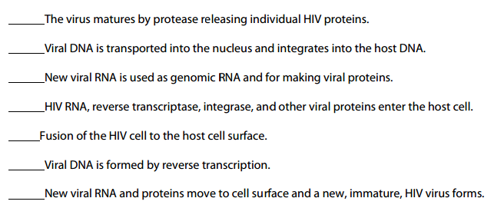

HIV Treatment
Task: use any of the previous links to explore how HIV infections are treated. Identify one current or proposed treatment method and explain how it works.

