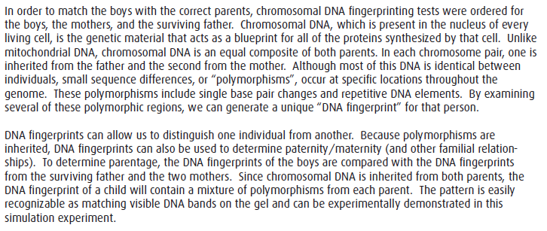
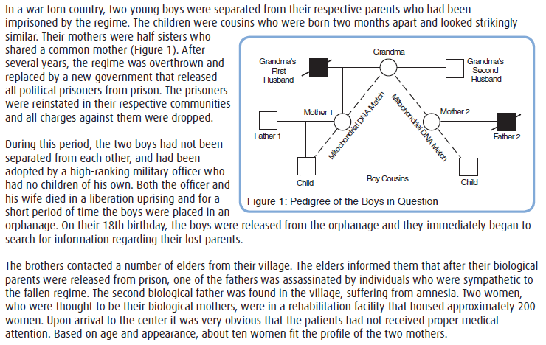
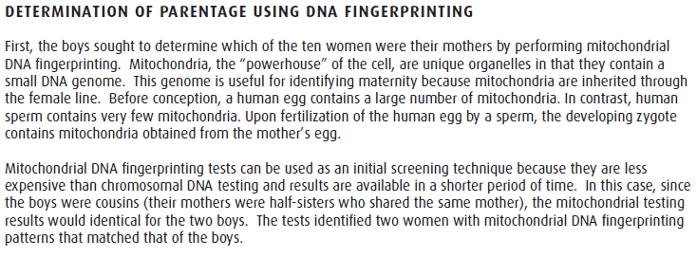

The results of the DNA fingerprint analysis are below:
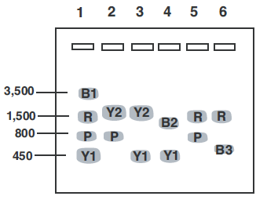
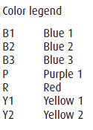
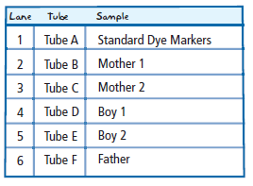

*Hint: It may be helpful to recreate a full color version of the gel and its bands on your own paper.

QUESTION: Who is the mother of Boy 1? Who is the mother of Boy 2? Which boy has found his father? Use the claim + evidence + reasoning format to give and support your answers. Be sure you have an answer (claim) for EACH question! Use a separate sheet of paper if you need more space.

