STATION 1:
- Match the flashcards together by their name, picture and function.

- Name and define FIVE organelles you struggled with in #1.

STATION 2:
- Draw a eukaryotic cell and a prokaryotic cell, AND label THREE structures unique to each type of cell.

STATION 3:
- Draw a diagram showing how the inputs and outputs of respiration and photosynthesis form a cycle.
- Show the movement of energy through respiration/photosynthesis by completing this flow chart:
________ GLUCOSE _________
STATION 4:
- Describe the central dogma of biology.
- You want a cell to differentiate into a brain cell. What part of the central dogma must be changed, why must this part be changed and in what way must it be changed?
STATION 5:
- For both transcription AND translation describe…
  - Where it happens
  - What it produces
  - What machinery makes the product
  - What building blocks make the product
STATION 6:
- Draw AND explain how DNA replication is “semi-conservative”

STATION 7:
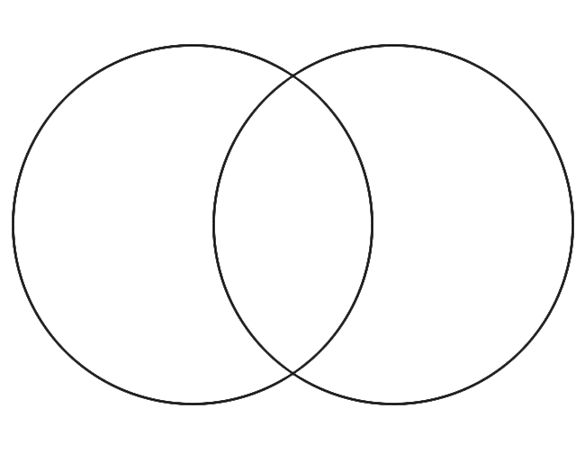
- Compare mitosis to meiosis with a Venn diagram
- What is the role of mitosis in asexual reproduction?
- What is the role of meiosis in sexual reproduction?
STATION 8:
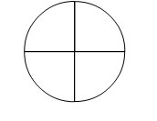
- Draw the cell cycle and label each stage with its name and purpose.
- Label the stages that make up “Interphase”.
- Why must Interphase be the same regardless of whether the cell goes through mitosis or meiosis?

