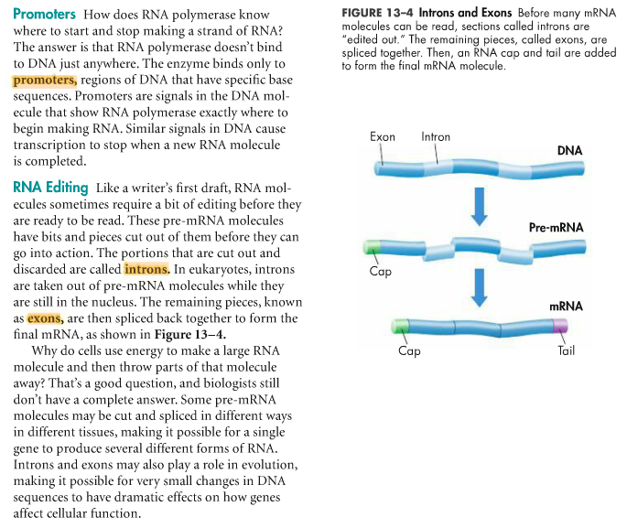

Define the following terms:

* Promoter
* Intron
* Exon

Describe the process of "splicing” or editing RNA.

Define the following terms:

* Promoter
* Intron
* Exon

Describe the process of "splicing” or editing RNA.