Name:_______________________________________ Date:________________ Period:_________

MITOSIS PRACTICE
Introduction: Mitosis can be observed in cells that are in a state of growth. In this lab, you will observe cells and identify which stage of cell division the cells are in. To help you do this, let's review what characteristics to look for at the different stages. Also remember, interphase is not technically a part of Mitosis, but it is part of the cell cycle and many of the cells you will be looking at are in interphase.

Stage | Distinguishing Characteristics
1. Identify each stage of the cell cycle on the chart below and describe what you would expect to see.

You will be looking at a slide of Allium, which is an onion root tip. Growth occurs when cells divide, so the root tips should have several cells in the process of cell division. View the root tip under the microscope and search for organized blocks of cells where nuclei are plainly visible.

2. Find FIVE cells that each have a DIFFERENT internal appearance and draw them in the boxes.

As you look at the cells of the root tip, you may notice that some cells seem to be empty inside (there is no dark nucleus or visible chromosomes). This is because these cells are three dimensional, but we are looking at just thin slices of them. If you slice a hard-boiled egg at random would you definitely see yolk in your slice? No. We want to continue to look at the cells but we will ignore any where we cannot see the genetic material (dark areas).

3. Looking at the photos below as a guide, identify the phase of each of the five cells you sketched in the previous table.
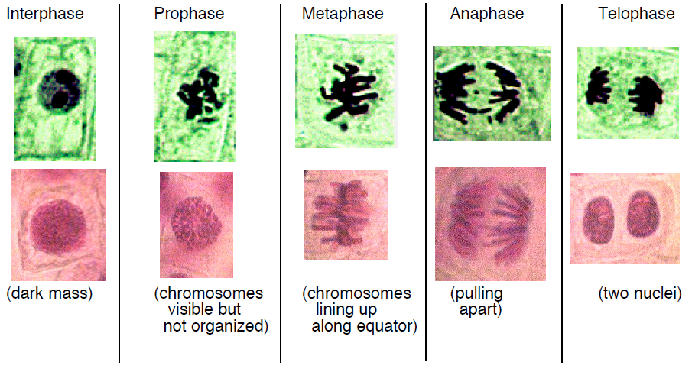

Find a computer station and click on the link provided or go to http://www.biology.arizona.edu/cell_bio/activities/cell_cycle/assignment.html.

4. Then click “Next” at the bottom of the page. Follow the directions on the screen to sort each cell image into the proper phase. Record the total number of cells in each phase in the chart below. Then calculate the percent of cells in each phase using the ratio below. Leave the percent as a DECIMAL.
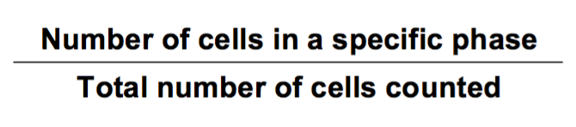

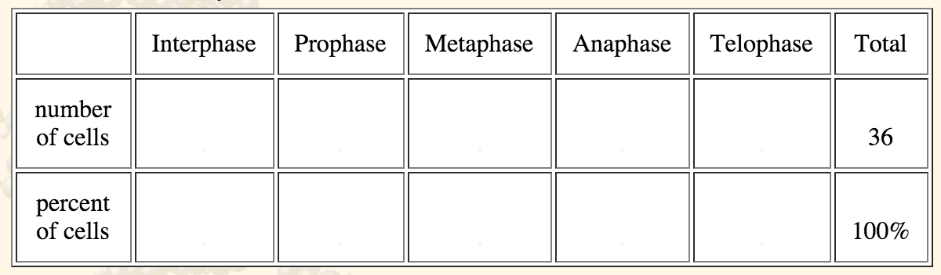
1.00

There is a direct relationship between the number of cells counted in a given stage of the cell cycle and the time that stage takes to complete. This may be calculated if the total time for the cell cycle is known. For onion root tip cells the cell cycle is roughly 960 minutes (16 hours). To determine the length of each phase multiply the total time in minutes by the percent of cells in that phase.

5. Record the length of each phase in minutes.

Interphase:______ Prophase: ______ Metaphase: ______ Anaphase: ______ Telophase: ______

6. Divide the length of each phase by the total cell cycle length (960 minutes) and multiply by 100 to calculate the percentage of the cell cycle spent in each phase.

Interphase:______ Prophase: ______ Metaphase: ______ Anaphase: ______ Telophase: ______
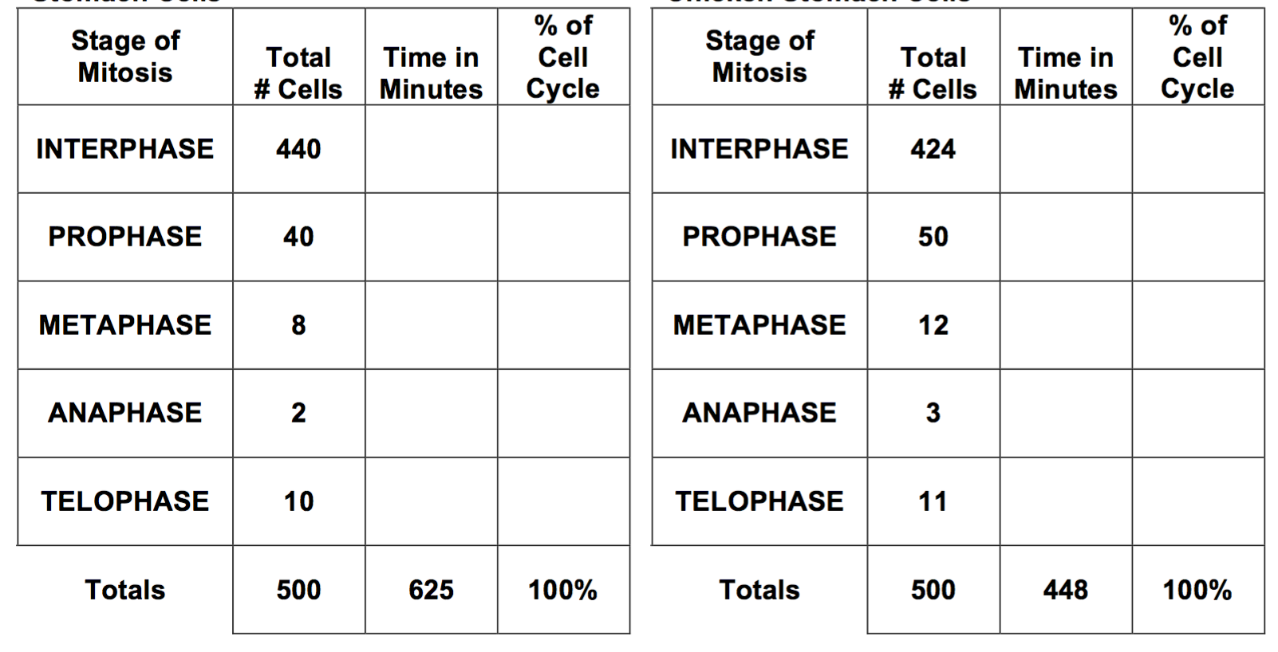
A key characteristic of cancer cells is that they are no longer constrained by the standard cell cycle controls that normally coordinate cell division activity. Consequently the timing of mitosis in cancer cells is altered. You may have heard of cancer cells being “runaway” which have no controls on their rate of reproduction. It is this characteristic that allows some cancer cells to grow and spread quite rapidly. In this section of the lab, you will analyze data to determine the differences in timing of mitosis between normal stomach cells and cancerous stomach cells of the chicken.
TABLE 1. MITOSIS IN NORMAL CHICKEN STOMACH CELLS
TABLE 2. MITOSIS IN CANCEROUS CHICKEN STOMACH CELLS

7. Study the data in Table 1 (Mitosis in Normal Chicken Stomach Cells). Assume that the total time needed for one normal mitotic division of these cells is 625 minutes. Calculate, in the same manner as before, the total time needed for each normal phase of mitosis. Also, calculate the percentage of the cell cycle spent in each phase. Enter these data in the appropriate column of Table 1.

8. Repeat the same analysis for the data in Table 2 (Mitosis in Cancerous Chicken Stomach Cells). In the case of cancer cells, however, the total time needed for one mitotic division is only 448 minutes. Also, calculate the percentage of the cell cycle spent in each phase. Enter these data in the appropriate column of Table 2.

