Name:______________________________________________ Date:_______________ Period:____________

Experimental treatments seek to stem rising tide of food allergies
By Shelby Lyon, Milwaukee Journal Sentinel
08.08.16
MILWAUKEE — For Amy Schwabe and her daughter Alex, candy can be scary.
Alex is one of 15 million Americans who suffer from food allergies. In her case, eggs and peanuts must be strictly avoided to prevent a potentially life-threatening allergic reaction. Even things like M&Ms, which don't actually contain peanuts, are a threat because they are produced in a facility that also uses peanuts.
"We can never just go to a bakery or grab doughnuts," said Schwabe, who also writes the Milwaukee Allergy Mom blog, "and going to a baseball game is terrifying."
Based on recent numbers, doctors expect 4.1 million children to develop a food allergy this year.
Ninety percent of cases will be to eight allergens: milk, eggs, peanuts, tree nuts, soy, wheat, fish and shellfish.
The CDC approximates the overall prevalence of childhood food allergies around 8 percent and rising, and doctors are puzzled as to why that number keeps increasing.
While there is no cure for food allergies, many experimental treatments are in the works to combat this growing problem, which puts an estimated $25 billion burden on the U.S. economy each year.
Food allergies first develop when a type of antibody called IgE is produced in response to a harmless food particle, or allergen.
These antibodies attach to the surface of a large immune cell, called a mast cell, and sensitize a person to that allergen.
On the next exposure, the bound antibodies recognize the particle and trigger the release of a cocktail of allergy-causing chemicals from sacs within the mast cell.
A typical reaction includes symptoms like mucus secretion, hives, vomiting and swelling, but severe allergies can trigger anaphylaxis, a reaction that restricts the airway and can lead to a dangerous drop in blood pressure.
"The bulk of studies suggest that all food allergies are increasing," said Robert Wood, director of allergy and immunology at Johns Hopkins University. "There's not one unifying hypothesis as to why, but there's probably five to 20 different things that have contributed to it."
The uptick in food allergies has been attributed to everything from disruptions in the gut microbiome to inadequate levels of vitamin D to processed foods.
One controversial theory for the increase is the "old friends" or "hygiene" hypothesis. It proposes that microbes and humans evolved together in a balancing act.
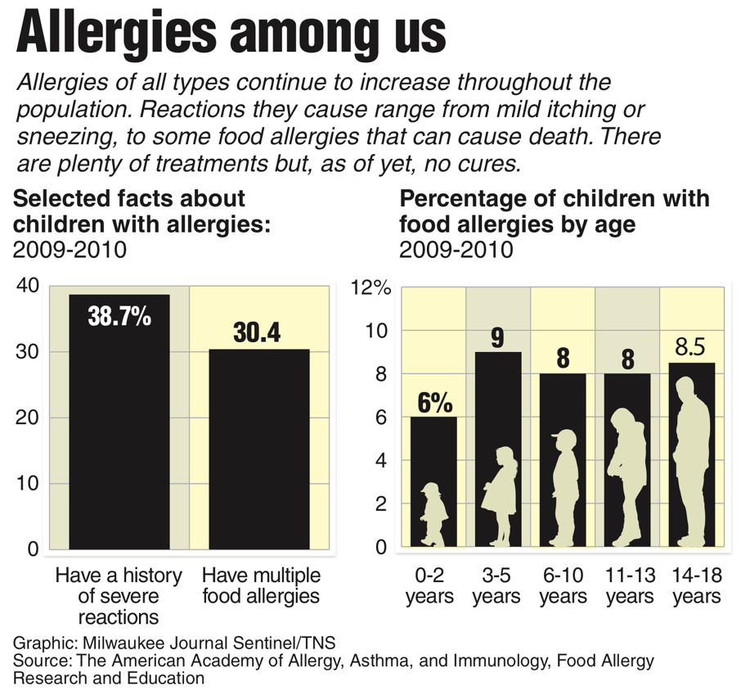
The human immune system developed mechanisms to combat the ever-present pathogens while they in turn acquired ways to down-regulate the immune system to avoid being detected.
When improved sanitation eliminated microbes and parasites in the body, the immune system continued to fight the pathogens that were not there.
In the absence of the dampening effects of infection, the immune response was too strong and reacted to food particles instead.
The "old friends" hypothesis is supported by the fact that inflammatory and immune-related diseases have been increasing for the past 60 years.
In regions of the world where parasitic infection rates are lower, such as North America and Oceania, the prevalence of allergies is higher — up to 70 percent higher.
Another reason behind the rise in food allergies might be found in recommendations concerning childhood food allergens.
The Learning Early About Peanut — or LEAP — allergy clinical trial took infants who had a high risk of developing a peanut allergy and assigned them to either an avoidance or consumption diet.
The consumption diet dictated that six grams of peanuts were to be eaten per week until the age of 5.
Children in the avoidance group were told not to eat any products containing peanuts.
Seventeen percent of individuals in the avoidance group developed a peanut allergy, while only 3 percent of those in the consumption group did so by age 5.
The results showed that exposure to a potential allergen at a very early age might have a protective effect against developing later food allergies.
"For decades allergists have been recommending that young infants avoid consuming allergenic foods such as peanut to prevent food allergies," said Gideon Lack, the lead investigator for the LEAP study, in a statement.
"Our findings suggest that this advice was incorrect and may have contributed to the rise in the peanut and other food allergies."
While a cause has not been identified, researchers have been attacking food allergies by exploring treatments that attempt to desensitize the immune system to an allergen, called immunotherapy. Three major categories of immunotherapy are in the works: oral, sublingual and epicutaneous.
The most effective form of immunotherapy is oral, which involves the ingestion of an allergen in powder or tablet form.
Each patient starts with a personally tailored dose well below the threshold for a reaction. The amount is then gradually increased until a maintenance dose is achieved.
Some clinical trials with oral have improved tolerance to the point where patients, both children and adults, can drink a glass of milk or eat a peanut butter cookie safely.
While oral immunotherapy has the potential to raise tolerance higher than either sublingual or epicutaneous, the risk of an adverse reaction is also higher.
About 80 percent of oral patients are desensitized to their allergen, but 10 percent to 20 percent typically withdraw from treatment due to serious side effects.
Viaskin is a form of epicutaneous that works by exposing only the top layers of skin to a small amount of peanut on a patch.
It's a little bit safer than oral, but the effects are more modest.
After 12 months, 50 percent of those treated with Viaskin could consume 300 mg of peanuts, a threshold high enough to prevent reactions to trace levels of peanuts from accidental contact.
However, Viaskin has been tested only in children and doesn't appear to be an effective treatment for adults.
The third therapy, sublingual, places drops containing minuscule doses of the allergen under the tongue. The site of application is key, according to Mary Morris, president of Allergy Associates of La Crosse. The area under the tongue contains a high number of the cells that recognize an allergen, but very few of the effector cells that trigger an allergic reaction.
"It's how infants are trained to develop tolerance. When sublingual therapy first worked, people didn't understand why. In retrospect we found out that there's actually this really beautiful system in place to show the immune system what it should and should not tolerate."
Because the allergen dose is small, sublingual leads to lower levels of desensitization, but is much safer.
Between 30 percent and 50 percent of patients typically experience tolerance to their food allergen.
These experimental treatments provide hope for those who suffer from food allergies.
"I'm really optimistic that we will treat allergies in the next five to 10 years," Morris said. Wood agreed.
"The future is very, very optimistic for food allergies," he said.
DISCUSSION QUESTIONS
- What is one question you would ask to better understand the information from the food allergy studies?
- If you had an allergy, which treatment would you select? Explain using evidence from the text.
- The second-to-last paragraph is optimistic about the outlook for allergy treatments. Was this statement supported by the evidence in the text? Explain.

