- Given the following genotypes, describe the phenotypes (albino is a recessive trait).

AA = _____________ Aa = _____________ aa = _____________

Give each family member in the pedigree the correct genotype for albinism:
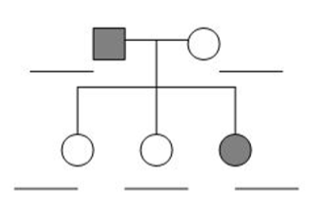

How many children does this family have? ______

What are the sexes of the children? ___________

- Use the pedigrees to predict whether the condition that is shown is a dominant or recessive trait.
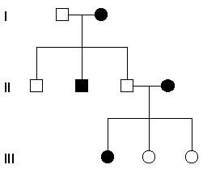
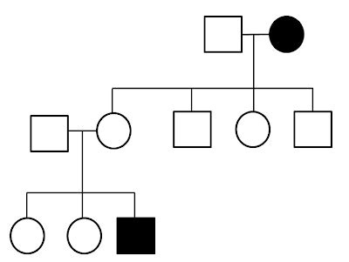
a. b.

____________________ _____________________
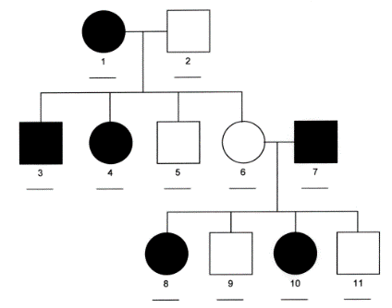
- The trait shown in the pedigree below is X-linked or autosomal? Explain your prediction.

- What does it mean if an individual has either symbol on the pedigree?

Give an example of their genotype: __________

- The following pedigree shows the presence of the allele for PKU in a single family.
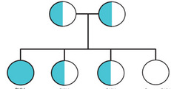

What is the genotype of the parents? ____________ X ____________

How many children in this family have the PKU trait? ____________

