The History of DNA
Follow the directions for each experiment to demonstrate your understanding of the history of DNA discovery.
Griffith’s Experiment - 1928
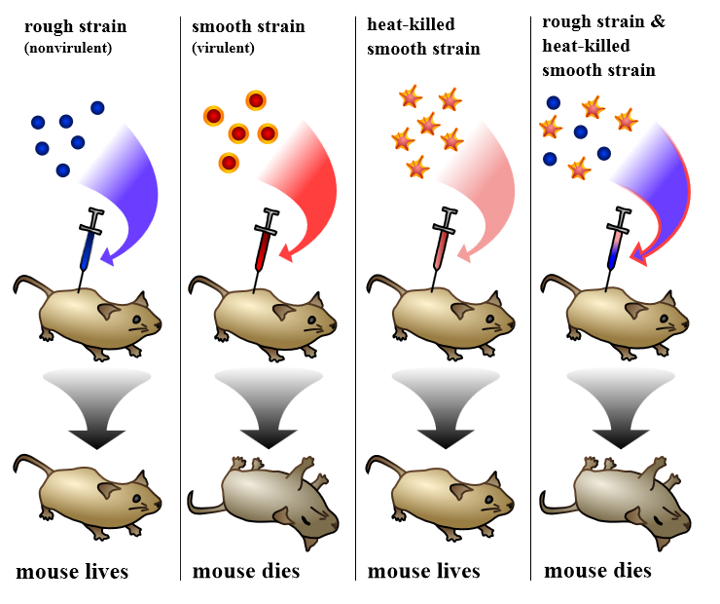
1. What is the independent variable in Griffith’s experiment? What is the dependent variable?

2. Why did Griffith need to show that the heat-killed bacteria did not make the mouse die?

3. Explain why the mix of bacteria killed the fourth mouse.

4. Imagine you are Griffith. In your own words, what can you conclude from the results of your experiment?

Avery, MacLeod and McCarty - 1944
At the time, Griffith had no idea what had caused the transformation in experiment. Other scientists picked up where he left off and tried to figure out what was causing the transformation. The first group of scientists to try were Oswald Avery, Colin MacLeod, and Maclyn McCarty.
Avery, MacLeod, and McCarty killed the bacteria in the same way as Griffith, and they then purified the different parts of the bacteria using digestive enzymes. See the diagrams below for their procedure and results.

5. What do protease and DNase do to the bacteria mixture in each treatment? Be specific.

6. What is the significance of the results from this experiment?

Hershey and Chase – 1952
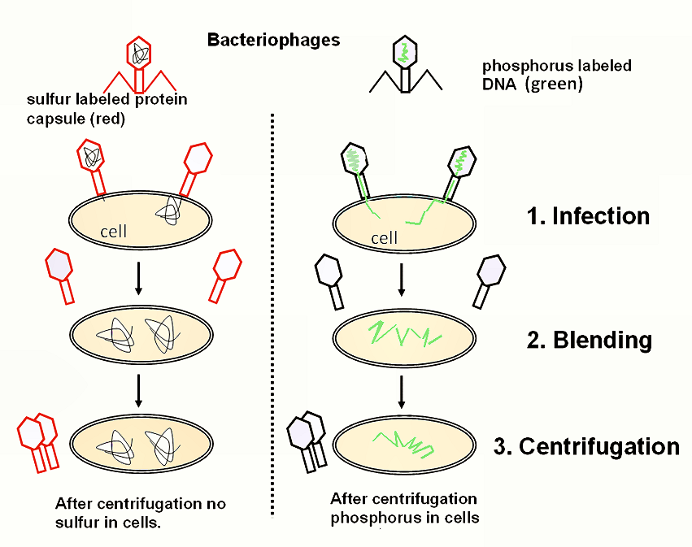
Alfred Hershey and Martha Chase took Avery’s experiment even further. Their results are summarized in the figure to the left.
7. Color the diagram to identify the sulfur-labeled protein (red) and the phosphorus-labeled DNA (green) in each treatment.
8. Based on Hershey and Chase’s results, how was the virus infecting the bacteria?

9. Based on the results, do you think that DNA or proteins carry genetic information? Defend your answer.

