There will be no late blight (or black spots) for these potatoes
By Associated Press, adapted by Newsela staff
11.06.16
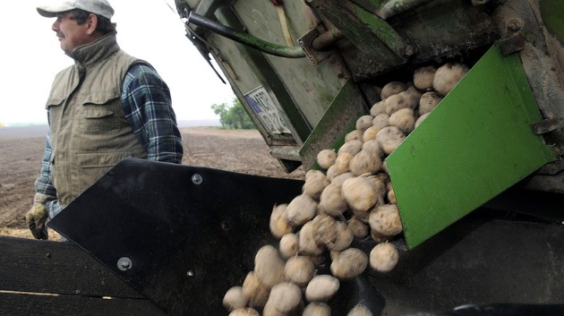
BOISE, Idaho — The U.S. Department of Agriculture has approved commercial planting of two types of potatoes that are genetically engineered to resist late blight, the disease that caused the Irish potato famine.
A farmer loads a planting device with genetically modified potatoes of the type "Amflora" prior to planting a test field near Buetow, Germany, May 5, 2009. AP Photo/Frank Hormann, File
The approval, announced on Friday, covers Idaho-based J.R. Simplot Company's Ranger Russet and Atlantic potato varieties. They are the second generation of the company's Innate potatoes, which are genetically modified using only the genes of other potatoes.
Genetically modified organisms (GMOs) are plant or animal products that have been re-engineered in a lab. Scientists use the DNA of bacteria, viruses or plants and animals. The purpose is to make seeds yield more crops or make the crops heartier, more tolerant of herbicides, and resistant to insects, disease and drought.

Company Is Proud Of Its New Product
J.R. Simplot Company says the potatoes will have reduced bruising and black spots and a longer shelf life. They will also have a reduced amount of a chemical created when potatoes are cooked at high temperatures. The chemical is believed to cause certain cancers.
"We obviously are very proud of these," said company spokesman Doug Cole.
The potatoes next must be reviewed by the Food and Drug Administration (FDA) and the U.S. Environmental Protection Agency (EPA).
The company says it expects those approvals in January and that the potatoes could enter the market next spring.
A variety of potato called the Russet Burbank, which has the same traits as these new potatoes, has already been approved by the Agriculture Department. It is also expected to gain EPA approval in January.

Using Genes From Other Potatoes
The company said the modified potatoes contain only potato genes. Their resistance to late blight comes from an Argentinian variety of potato that naturally produced a defense.
Late blight continues to be a major problem for potato growers around the world, especially in wetter regions. Company officials say the new types of potatoes will help protect crops and reduce the use of pesticide spray up to 45 percent.
The reduction in bruising, Cole said, could reduce waste and increase by 15 percent the top-quality potatoes coming out of fields, which sell for more than bruised potatoes.
Cole also said the new varieties of potatoes can be kept in cold storage longer. Conventional potatoes can turn a dark color when cooked after they were kept cold for too long. Better storage could help the potato chip industry by reducing trucking costs, Cole said.

Innate Potatoes Make Up 1 Percent Of All Sales
The company's first generation of Innate potatoes has already been selling to consumers for more than a year. Those potatoes, sold under the White Russet label, have reduced bruising and reduced potential carcinogens when cooked, but not resistance to late blight or enhanced cold storage.
Cole said about 40 million pounds of the first generation potatoes have been sold to consumers in more than 35 states. He said that's about 1 percent of all potato sales. Of the 40 million pounds, he said about two-thirds went to produce sections of stores.

GMOs Give Some People Pause
There is no evidence that GMOs are unsafe to eat, but for some people, altering the genetic code of foods presents a moral issue. McDonald's has rejected using these potatoes for its French fries.
The food industry has also faced pressure from retailers as consumer awareness of genetically modified foods has increased. Retailer Whole Foods has said it plans to label GMO products in all its U.S. and Canadian stores by 2018. A company spokeswoman declined to comment over the phone on Monday, and the company didn't immediately respond to an emailed question from The Associated Press about whether it would consider selling the potatoes in its stores.

Simplot Launches PR Campaign
Simplot has been fighting back with a public relations campaign this year and two female athletes.
Kristin Armstrong, a Boise resident and three-time Olympic gold medalist in cycling, touts the nutritional values of the White Russet potatoes.
To demonstrate resistance to bruising, mixed martial artist and former UFC women's bantamweight champion Holly Holm recently used her skills on a hanging bag of White Russets. The company said the potatoes survived and proved hard to bruise.

QUESTIONS:
- Describe the main idea of this article.

- Explain why altering the genetic code of foods might present a moral issue for some people.

- CER PARAGRAPH: How is transgenic technology benefitting the potato industry? Include 2 evidences from the text in your answer. Cite your evidence using quotation marks and the following citation format:
My answer is supported by this “Sentence” (Paragraph #).

