Name:_____________________________________________

How Do Abiotic Factors Affect Distribution of Organisms?
Go to http://wps.aw.com/bc_campbell_biology_10_oa/244/62525/16006432.cw/index.html. Then find the activity for Chapter 52.
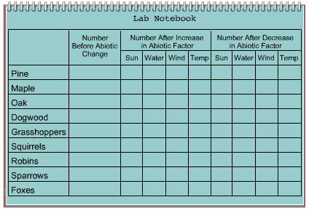
Changes in abiotic factors such as sunlight, water, and temperature will affect the animal and plant composition of an ecosystem. Scientists are developing an area of research called urban ecology that involves studying the impacts of urbanization and global climate change on the world's biomes. In this activity you will be using a simple model for observing the ecological impact that occurs when you change single abiotic factors. First, click on the Lab Notebook window and record the number of each type of animal and plant. Then click on one of the abiotic factor buttons to look at the impact of altering that factor.

- Summarize and explain the effects of an increase in sunlight.

- Summarize and explain the effects of a decrease in sunlight.

- Summarize and explain the effects of an increase in water.

- Summarize and explain the effects of a decrease in water.

- Summarize and explain the effects of an increase in wind.

- Summarize and explain the effects of a decrease in wind.

- Summarize and explain the effects of an increase in temperature.

- Summarize and explain the effects of a decrease in temperature.

