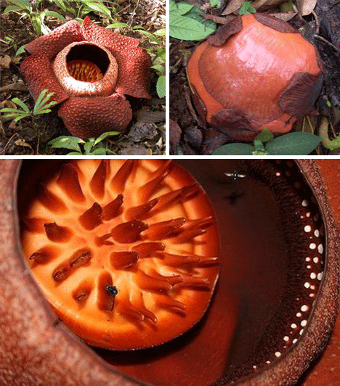
Rafflesia is a type of plant that parasitically attaches to the roots and vines of other plants, and is mainly visible because of its large flowers, which can weigh up to 22 pounds. These flowers are notable for looking and smelling like rotting flesh, which attracts flies.

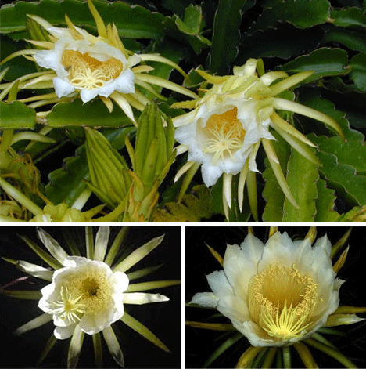

Nightblooming Cereus flowers grow in deserts with incredibly low water levels. They only bloom at night, one or two nights a year.

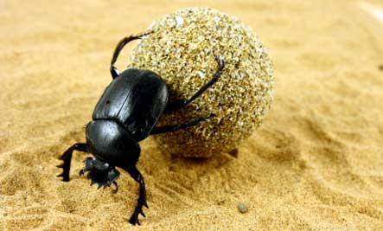
Dung beetles are already world-renowned for their ability to roll a ball of excrement across great distances, but recent evidence suggests that a certain species of dung beetle (African Scarabaeus zambesianus) may be capable of another impressive skill: navigation using polarized light from the moon. These insects are often observed to travel in a straight line with their dung balls, despite whatever obstacles they may encounter. It seems that these insects rely on the patterns created when moonlight interacts with particles in the atmosphere (polarization) to navigate in a straight line. When no moonlight is available, the dung beetles tend to veer, curve or otherwise meander.
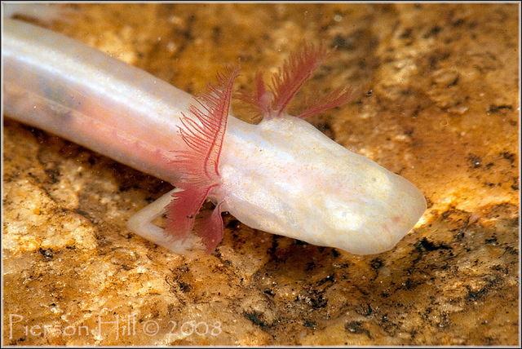
Georgia blind salamanders have a white body with a yellow or pink tint, red external gills, and a long flat head. And while juveniles of this species exhibit minute eyespots, the adults have no eyes! This species of salamander is confined to underground streams and pools in caves and sinkholes where it typically lives in complete darkness.

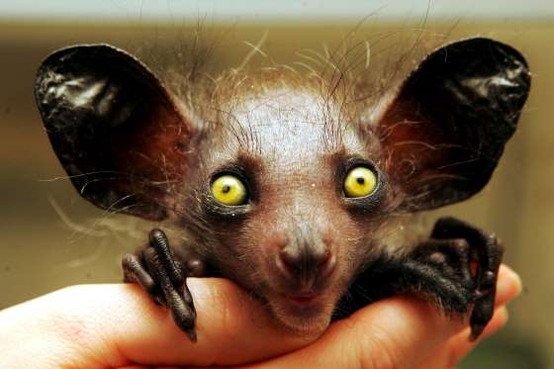
A native of Madagascar, the aye-aye feeds on insects hiding inside of trees. It has rodent-like teeth and a long middle finger.

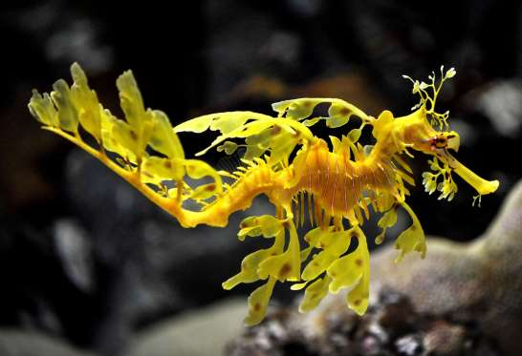
The leafy seadragon is covered with leaf-like appendages. It lives in marine habitats that also support a variety of aquatic vegetation.
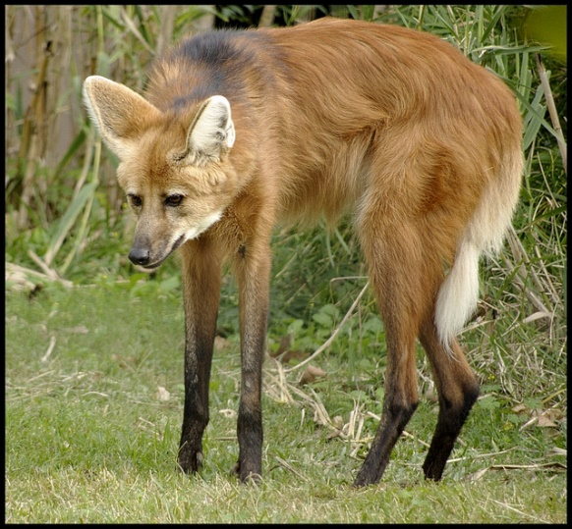
The maned wolf, or Chrysocyon brachyurus, is a member of the canid family, which includes dogs wolves, and foxes. However, they’re only distantly related to any other canid species. With its reddish fur and erect ears, the maned wolf looks a lot like your typical red fox, with one glaring exception—it has long, delicate legs that would look more at home on an African gazelle than any kind of wolf. Its habitat is in fields of tall grass in South America.

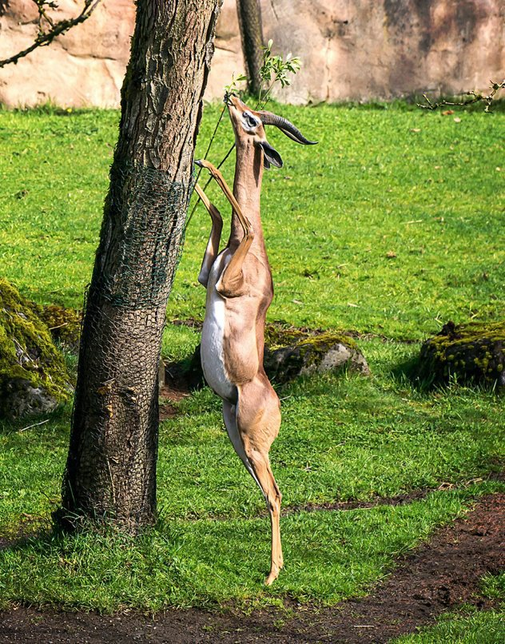
Also known as the Waller’s gazelle, gerenuks (Litocranius walleri) have enormously elongated necks and thin, spindly legs, which provide them with a unique feeding opportunity. Rather than graze from grass on the ground like most antelopes, gerenuks stand upright on their hind legs to feed almost exclusively on the leaves and shoots of the acacia trees which dot the African savannas. There are 91 species of antelope in the world, and most of them live in Africa with the gerenuk.

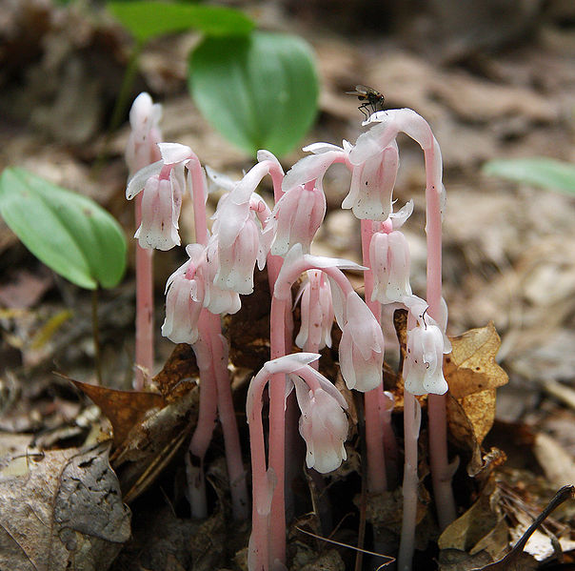
The Woodland Pinedrops Plant and the Indian Pipe Plant are heterotrophs! They completely lack chlorophyll and spend most of their time underground, with their above ground time dedicated to growing a flower and producing seed. They are typically found in the shade of trees within the deep litter. In the specific case of the Indian Pipe Plant, fungus are located in the Pipe Plant’s short, web-like root system. The roots connect to the conifer trees the Pipe Plant is growing beneath, allowing the fungus to carry sugars from the conifer to the Pipe Plant, therefore, the Pipe Plant is actually parasitic to the fungus partner.

