STRUCTURAL ADAPTATIONS OF LIVING THINGS: NOTES & PRACTICE
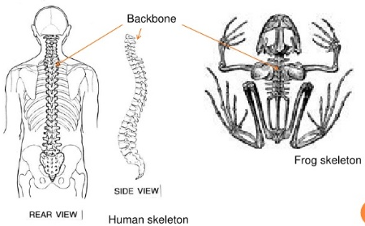
Movement:
- Many animals have an endoskeleton (internal skeleton) that helps them move.
  - What structures allow protista to move? HINT: There are 3...

- Plants and fungi are sessile (they cannot move). Plants have a vascular root system for obtaining and transporting water and nutrients. Fungi have a network of hyphae that secrete digestive enzymes and then absorb the nutrients afterward.
  - Explain the advantage of roots and hyphae for organisms that cannot move in response to their environment.

Defense:
- Animals can blend in to the pattern/colors of their environment (camouflage), or copy the phenotype of a dangerous animal (mimicry).
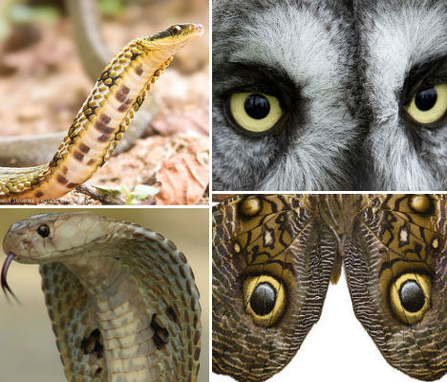
  - Explain the advantage for an animal that uses camouflage.

  - Explain the advantage for an animal that uses mimicry.

Gas Exchange:
- Animals breathe in different ways – some animals, like worms, breathe through their skin; other animals breathe using lungs or gills. All animals, however, must have moisture for effective gas exchange (CO2 released, O2 taken in).
  - Many animals, like humans, can keep their internal respiratory structures moist. How do animals like fish and worms – that don’t have internal lungs – keep their respiratory structures moist?

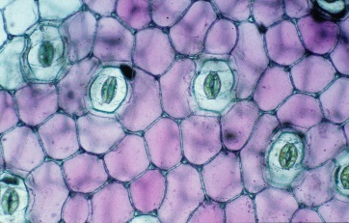
- Plants must also exchange gases for not only cellular respiration, but also photosynthesis. Their leaves contain pores called stomata that can open and close.
  - What gas is taken in by plants for photosynthesis? What gas is released by plants as a product of photosynthesis?

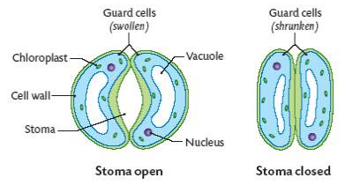
Guard cells control the opening of stomata. When the guard cells swell with water, the pore opens; when the cells lose water, the pore closes.

Osmoregulation:
- Living things need just the right amount of water to survive. Aquatic animals regulate water based on the salt content of their environment. Freshwater fish produce lots of dilute urine to get rid of excess water, while saltwater fish drink water and remove excess salt via their gills.
  - Draw an arrow showing the movement of water in each scenario below.
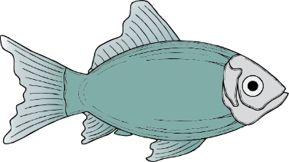
10% salt
0% salt
30% salt
10% salt

  - What structure do protists use to control the amount of water they store?

- Terrestrial animals, which live on land, produce concentrated urine to conserve water.
  - Why would these kinds of animals need to conserve water?

Thermoregulation:
- Animals stay warm using a layer of fat. Mammals are unique in that they also have a coat of fur/hair.
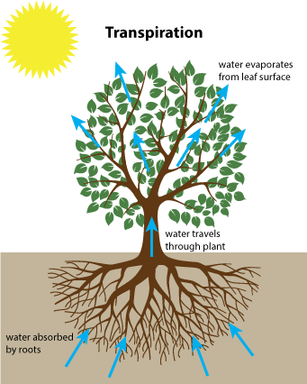
  - What benefit do fur/hair and fat provide for animals?

- Animals stay cool by sweating or panting. Plants stay cool by releasing water, like sweating, in a process called transpiration.
  - What do all these cooling adaptations have in common? Give an example of when you have noticed this cooling effect.

Nutrient Transport:
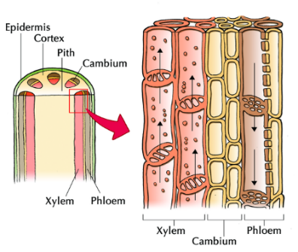
- Plants have vessels called xylem for transporting water from roots to leaves, and phloem for transporting sugars from leaves to roots.
  - How are xylem and phloem similar to the circulatory system in animals?

