BACTERIAL TRANSFORMATION VIRTUAL LAB
Find the link on the class website or go to this website to access the simulation: http://www.classzone.com/books/hs/ca/sc/bio_07/virtual_labs/virtualLabs.html
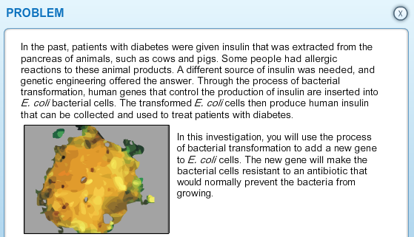
PART 1: Explore the lab and all of your materials. Record the purpose of the following materials below:
Calcium chloride solution:
Plasmids with amp^{R}:
Ice water bath:
Warm water bath:
Agar with ampicillin:
Agar without ampicillin:
Incubator:
PART 2: Click on the Procedure tab at the top of your screen. Record your predictions for how the E.coli will grow in the absence and presence of ampicillin. You will need to click the Lab Notebook and enter some text into each box in order to proceed in the simulation.
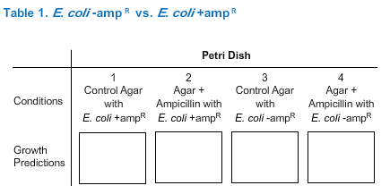
Summarize what you did in each of the steps of bacterial transformation below. Step 1 in the table corresponds to Step 2 of the simulation.
Step | Summary/Purpose
1
2
3
4
5
6
7
8

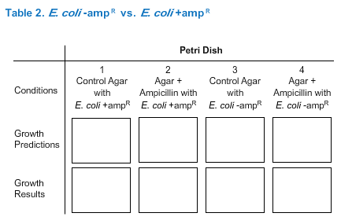
PART 3: Observe the growth of bacterial colonies on each of your plates and record the results below. You will need to click the Lab Notebook and enter some text into each box in order to proceed in the simulation.
See Table 1

PART 4: Answer the post-lab questions below. It may help to read the Background tab in the simulation.
