Name:__________________________________________________________ Date:____________________ Period:____
CARBON CYCLE BOOK SEARCH
First, let’s get a textbook! Next, use the page numbers provided to identify the pages you will read to answer each set of questions below.
PAGE 45
- What is it about carbon that allows it to form the molecules of life?

- When carbon binds to itself what two structures can it create?

PAGES 46-49
- What are “macromolecules”?

- What are the four major groups of macromolecules?

- What is the function of carbohydrates?

- How do many organisms store extra sugar?

- Draw a picture of what this storage molecule looks like:

- In animals, this storage molecule is called:

- What complex carbohydrate provides plants with their strength and rigidity?

- What are examples of lipids?

- What are the two functions of lipids?

- Looking at Figure 2-15, what two molecules bind together to make a lipid?

- What are the three parts of a nucleotide?

- What is the function of nucleic acid?

- Name two kinds of nucleic acids we’ve learned in class:

- What are the building blocks of proteins?

- What are three functions of proteins?

- How many levels of structure do proteins have? _____

- Using the figures on these pages, match each macromolecule with its correct structure.
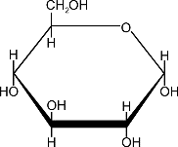
Lipid ___
Protein ___ A. C.
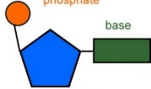
Nucleic acid ___
Carbohydrate ___ B. D.
- Again, looking at the figures, what chemical elements make up these macromolecules?
(HINT: There should be four!)

PAGES 79
- Read the “Think About It” section. Now double check your answer to #20. What chemical elements make up most living organisms again?

- How does matter move through the biosphere?

- How does this recycling occur? Don’t forget to name the three processes involved!

- Does matter get destroyed in these cycles? Explain.

PAGES 82-83
- What element is often used in describing the life on planet Earth? _______________

- Describe two ways carbon can be found in living things:

- Describe how carbon can be found in the earth:

- Describe two ways carbon can be released into the atmosphere:

- On the diagram on the next page, draw arrows to show one of each of these processes in the carbon cycle: biological, human, geological and physical/chemical. Color code the arrows using the key in Figure 3-17. Use the blank space to describe each process.
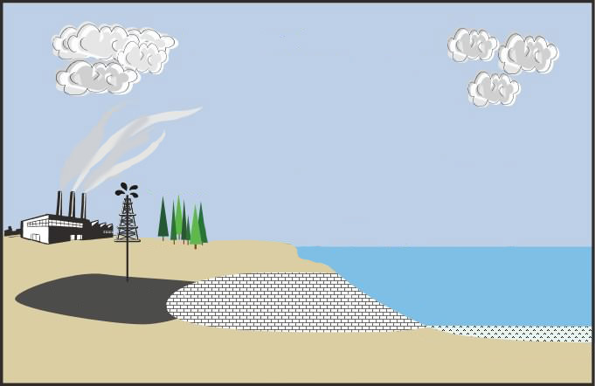

Biological:

Human:

Geological:

Physical/Chemical:

