DEBATE FORMAT & RUBRIC

Debating is a formal, ritualized way of settling disagreements. Instead of yelling or fighting, people prepare their arguments in a structured logical way and present them objectively. Just as important, they and their opponents are forced to anticipate and think about the other side's point of view, in order to prepare a response.
Debating is a foundation of our civilized society. We have formal debates in the Provincial Legislature and the Federal House of Commons. People in our society have radically different ideas on how to run the country but after debate between the government and the opposition, a compromise is hopefully reached which benefits the greatest number of people.
Students who learn how to debate, are often more open to other people's points of view, have sharper critical thinking skills and know how to settle disputes with dignity. This is an important skill to have when discussing bioethical issues in genetics and biology.

The format of our debates will be as follows:
Speaker | Time | Who | What | Details
1 | 2 min | PRO | Introduction | Main thesis, we are going to show you, define topic
2 | 2 min | CON | Introduction | Main thesis, we are going to show you, define topic
3 | 2 min | PRO | List Proof | Supporting facts, statistics, quotes
4 | 2 min | CON | List Proof | Supporting facts, statistics, quotes
5 | 2 min | PRO | Rebuttal to other group | Prepared counter arguments, quotes, facts, on your feet response to speakers 2 and 4
6 | 2 min | CON | Rebuttal to other group | Counter arguments, quotes, facts, on your feet response to speakers 1 and 3
7 | 2 min | PRO | Final Summary | Last chance at re-rebuttal, summing up. last appeal
8 | 2 min | CON | Final Summary | Last chance at re-rebuttal, summing up. last appeal

You will sign up for your first debate date on the sign-up sheet provided. You will actively debate two times this school year. The other students who sign up for the same date will be your debate group. When it is your day to debate you will follow the format described for your grade. You will research both sides of the topic and on debate day you will flip a coin to determine which side you will argue. When it is NOT your debate day, you will still research the topic to become an informed audience member. Non-debaters will conduct research, choose a stance on the bioethical question and write a one-page essay stating and defending their position. Essays will be scored using the same debate rubric with the “Respect for Other Team” criteria omitted. The debate rubric can be found on the backside of this reference sheet.

Topics for our Quarter 1 & 2 debates are:
1 Genetically-modified foods
2 Stem cell research
3 Genetic testing of newborns
4 E-cigarettes as safe smoking alternative
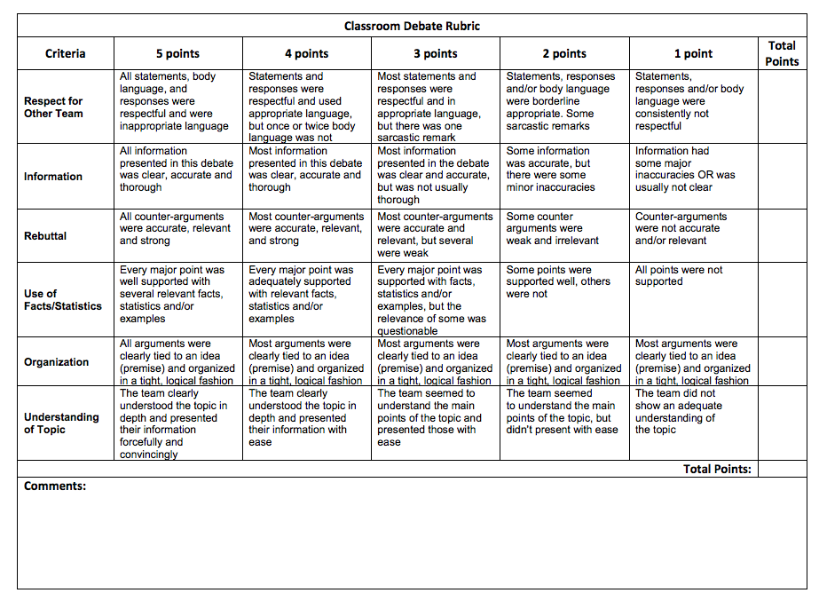
THE DATE OF MY DEBATE IS: ________________________________

MY DEBATE TOPIC WILL BE: _________________________________

MY DEBATE PARTNERS ARE: _________________________________

_________________________________

_________________________________

