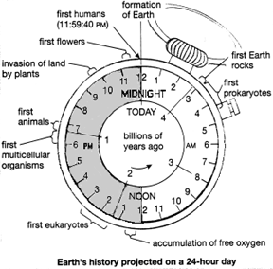
Earth’s History Projected on a 24 Hour Day… The Clock Assignment
Name______________________________________ Period ___________________
In this assignment you will be drawing and labeling different events in the history of the earth. You will be doing work on the 24 hour clock.
Procedure:
- Every hour on the 24 hour clock represents 200 Millions of years. You need to start at midnight and move counter clockwise and label the times of the earth in millions of years. Example: at 11p.m. on the clock you would write 200 MYA. At 7 p.m. you would write 1 billion years ago.
- Now Label the following items on the clock.
  - At 5 a.m. the very first rocks were formed on the earth
  - At 6 a.m. the first single celled organism fossils are found
  - At 8 a.m. the first photosynthetic bacteria are found
  - At 1 p.m. the first Multi-Celled organisms are found
  - At 9:18 p.m. the first shelled fish and invertebrates are found
  - At 9:30 p.m. the first fish are found
  - At 9:57 p.m. the first land plants appear
  - At 10:00 p.m. the first insects on land appear
  - At 10:06 p.m. the first amphibians appear
  - At 10:18 p.m. the first Reptiles appear
  - At 10:51 p.m. the first Conifers appear (trees like pines)
  - At 10:57 p.m. the dinosaurs appear and flourish
  - At 11:16 p.m. the first birds appear
  - At 11:22 p.m. the first flowering plants appear
  - At 11:30 p.m. the dinosaurs went extinct
  - At 11:52 p.m. grasses appear
  - At 11:59 p.m. the first early humans appear
Answer the following questions about the clock
- Explain how the complexity of organisms changes over time:

- Where do you see the most biodiversity (most organisms) on the clock? Explain why this might be

- Photosynthesis appears quite early in the timeline. Before photosynthesis there was no oxygen in the atmosphere. Explain why the evolution of photosynthesis led to the appearance of animals that breathe oxygen:

This is a 24 hour clock. Keep this in mind as you label the clock
1
1
3 A.M.
9 A.M.
6 A.M.
9 P.M.
3 P.M.
6 P.M.
NOON
Midnight

