Name: Period: Date:
Celeste and Aaron know that saltwater fish cannot survive for very long in fresh water. Saltwater fish are able to survive in saltwater because their kidneys have adapted to allow their cells to have a different concentration of salt and water compared to the cells of a freshwater fish. Celeste and Aaron investigated the effect of different concentrations of saltwater on the number of deaths of saltwater fish.
Question: What is the effect of different saltwater solutions on the number of fish deaths in one week?
Materials:
180 saltwater fish  4 fish tanks | 0% saltwater solution  1.5% saltwater solution  2.5% saltwater solution  3.5% saltwater solution

Controlled Experimental Setup

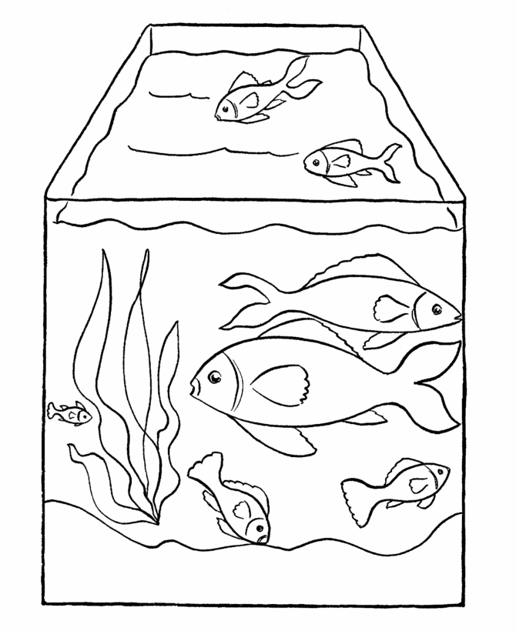
Tank 1: 0% salt Tank 2: 1.5% salt Tank 3: 2.5% salt Tank 4: 3.5% salt

Procedure:
Controlled variables: number of fish, type of fish, size of tank
Manipulated variable: percent of salt in water
Responding variable: number of fish deaths

- Put 3 gallons of 0% saltwater into Tank 1, 3 gallons of 1.5% saltwater into Tank 2, 3 gallons of 2.5% saltwater into Tank 3, and 3 gallons of 3.5% saltwater into Tank 4.
- Add 20 saltwater fish to each tank.
- Leave the fish in the tanks for 1 week.
- Record how many fish die in each tank at the end of the week.
- Repeat steps 1-4 three times.
- Calculate and record the average of the four trials for each salt solution.

Data:
Percent salt solution vs. Number of fish deaths

Percent Salt in Water (%) | Fish Deaths (number)
 | Trial 1 | Trial 2 | Trial 3 | Average
0% salt | 20 | 20 | 20 | 20
1.5% salt | 15 | 14 | 17 | 12
2.5% salt | 7 | 9 | 5 | 7
3.5% salt | 1 | 2 | 0 | 1

Write a conclusion for this experiment.
In your conclusion, be sure to:
- Answer the experimental question.
- Include supporting data from the Percent salt solution vs. Number fish deaths table.
- Explain how these data support your conclusion.
- Provide a scientific explanation for the trend in the data.
Question: What is the effect of different saltwater solutions on the number of fish deaths in one week?
Conclusion:
Present?
Conclusive statement
Supporting data (low) & high
Explanation of data
Scientific Explanation
*add another piece of paper if necessary

