Fingerprint Lab

Background Information: Fingerprints are an impression of the lines on the inner surface of the thumb and fingers. The patterns are made by tiny ridges in the skin. The ridges on our fingertips help us to grip objects. When we touch an object, the oil and perspiration on our skin leave behind a fingerprint. Investigators dust these with a fine powder to make the patterns visible and then, lift the fingerprints with sticky paper.

Fingerprints are permanent details that are created before you are born. They are created by the random migration of skin cells during your embryological development. Remember that phenotype (e.g., fingerprints) is caused by a combination of genotype (DNA), environment (e.g., diet, pollution, social class) and random developmental events (e.g., migration of cells). Fingerprints do not change unless they are scarred, affected by skin disease, or after death. No two fingerprints are the same, not even on the same person or on identical twins. The most common fingerprint patterns include whorls, arches and loops, although some people show double loops and other combinations. In the general population, about 65% of all fingerprints are loops; 30% are whorls; and only 5% are arches.

Arch Loop Whorl
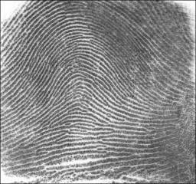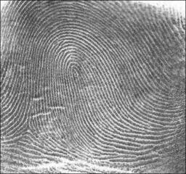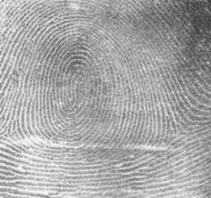
Arches look like hills that point upward (don’t bend left or right). The ridge lines enter from one side and exit on the other side. There are no deltas. Loops are taller than arches and bend slightly to the left or right. The ridge lines enter and exit from the same side. There is usually one delta. The example to the right is a Left Loop, since it points to the left. The ridges enter and exit from the right side. Whorls can be made of concentric rings (like a bull’s eye) or 2 loops pointing in opposite directions. They generally have two deltas.

Procedure:
- Rub the pencil on the scratch paper until there is a dark smudge of graphite.
- Rub each finger on the smudge until the fingertip is covered with graphite.
- Place a small piece of tape over your fingertip. Press the tape down gently.
- Carefully remove the tape and stick it in the appropriate square in table 1.
- Repeat the process for the other four fingers of your hand.
- Look at your fingerprints under the microscope and try to identify which type you have. Record the type of fingerprint pattern beneath each print
- Record the data for your class in table 2
- Make a BAR GRAPH for your class data

Table 1: Individual fingerprints
Finger | Thumb | Index | Middle | Ring | Pinky
Print
Pattern

Table 2: Class Data
 | Loop | Arch | Whorl | Total
Total number of each type of print
% |  |  |  | 100%

Analysis
- Which is the most common type of fingerprint in your class?________________________________

- What were the percentages of each type of print? Were they close to the predicted percentages given in the background information above?
____________________________________________________

_________________________________________________________________________________

- Did you have the same fingerprint pattern on each of your fingers?___________________________

- Are skin cells produced by mitosis or meiosis?___________________________________________

- Are they clones? Explain.____________________________________________________________

_________________________________________________________________________________

_________________________________________________________________________________

- Explain how some skin cells might end up differently than other skin cells. _____________________

_________________________________________________________________________________

_________________________________________________________________________________

- Explain how different fingers on the same hand could end up with different fingerprints.__________

_________________________________________________________________________________

