Defining Speciation
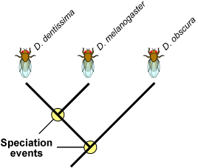
Speciation is an event that produces two or more separate species from one single population within a species. Imagine that you are looking at a tip of the tree of life that constitutes a species of fruit fly. Move down the phylogeny to where your fruit fly twig is connected to the rest of the tree. That branching point, and every other branching point on the tree, is a speciation event. At that point genetic changes etc. resulted in two separate fruit fly lineages, where previously there had just been one lineage. But why and how did it happen?
The branching points on this partial Drosophila phylogeny represent long past speciation events that could have taken place many thousands of years ago.
Here is one scenario that exemplifies how speciation can happen:

The scene: a population of wild fruit flies minding its own business on several bunches of rotting bananas, cheerfully laying their eggs in the mushy fruit...
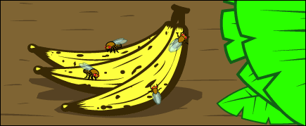
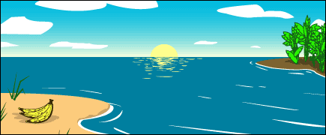
Disaster strikes: A hurricane washes the bananas and the immature fruit flies they contain out to sea. The banana bunch eventually washes up on an island off the coast of the mainland. The fruit flies mature and emerge from their slimy nursery onto the lonely island. The two portions of the population, mainland fruit flies and island fruit flies, are now too far apart for gene flow to unite them. At this point, speciation has not occurred—any fruit flies that got back to the mainland could mate and produce healthy offspring with the mainland flies.
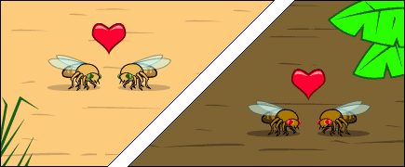
The populations diverge: Ecological conditions are slightly different on the island, and the island population evolves under different selective pressures and experiences different random events than the mainland population does. Morphology (phenotypes), food preferences, and courtship displays change over the course of many generations of natural selection.

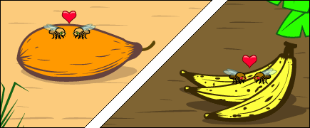
What might have caused that to happen? Different fruits were abundant on the island. The island population was selected to specialize on a particular type of fruit and evolved a different food preference from the mainland flies. Since there were no bananas to eat and lay their eggs in they had to make use of the fruit that was available or die out!
Could this small difference be a barrier to gene flow with the mainland flies? Yes, if the flies find mates by hanging out on preferred foods, then if they return to the mainland, they will not end up mating with mainland flies because of this different food preference. Gene flow would be greatly reduced; and once gene flow between the two species is stopped or reduced, larger genetic differences between the species can accumulate.
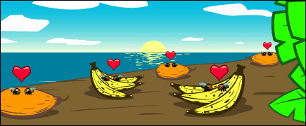
So we meet again: When another storm reintroduces the island flies to the mainland, they will not readily mate with the mainland flies since they’ve evolved different courtship behaviors. The few that do mate with the mainland flies, produce inviable eggs because of other genetic differences between the two populations. The lineage has split now that genes cannot flow between the populations.

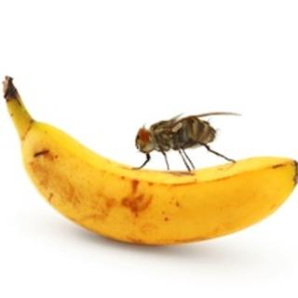
Name____________________________________________________ Period______________
Fruit Fly Speciation
1- Read the first paragraph and look at the first picture.
a. Define Speciation from the first line.

b. Explain what the little circles mean where it says speciation event?

c. Define Phylogeny

2- Where do the fruit flies lay their Eggs and why do you think it is important to them that there is always a supply of bananas?

3- Explain what happens during the paragraph entitled: Disaster Strikes!

4-Define Gene Flow:

5- What do you think the paper means when it says that gene flow can no longer happen between the two populations?

6- Explain: at this point are the two populations of fruit fly (ISLAND and MAINLAND) now considered a new species because they are separated by the sea?

7- What would be some of the different selective pressures that you think the island population would face now that they are off the mainland? Hint: read the last sentence in Pop Diverge!

8- What inference does the author make about what type of selective pressures the flies might have encountered?

9- Do you think this type of selective pressure (different fruit source) could serve as the type of selective barrier that could cause lack of gene flow?

10- Explain what can happen to a population if gene flow is reduced over a long period of time. You must talk about genetic differences and mutation.

11- Now finally a storm blows some of the island fruit flies back to the mainland. What happens when some of the island flies mate with the mainland flies?

12- Would we now consider these two populations different species or would they still just be considered different populations?

