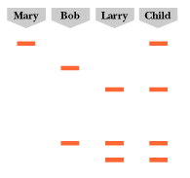
- The diagram below shows the DNA fingerprints of Mary, her child, and two men who are Mary’s ex-boyfriends. Which man is most likely the father of Mary’s child? Explain your answer.

- What kind of molecule was used to digest the DNA samples from Mary, Bob, Larry and the child into fragments?

- The DNA fragments for each sample in a gel create a unique pattern of bands called a “DNA fingerprint”. How is this different from an actual fingerprint? How is it similar?

- The diagram below shows an agarose gel before it has undergone electrophoresis. The gel will be placed in a gel box that will provide an electrical current which will flow through the gel and allow the DNA to travel. Label the following on the diagram:
  - The end of the gel that should be placed at the negative (--) electrode.
  - The end of the gel that should be placed at the positive (+) electrode.
  - Where the DNA samples should be loaded.

A B C
1

3
4

- The gel from Question 4 is run and the following bands appear.
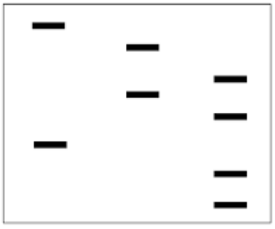
  - Which band should be the shortest? Why?
2

  - Which band should be the longest? Why?
5

