Is Yeast Alive?

Pre-Lab Questions (Please answer in your notebook)

- What is yeast?
- Do you consider yeast to be alive? Why or why not? Support your answer using at least 2 characteristics of life.

Background Information

Today we will carry out an indirect test for metabolism. Metabolism refers to the chemical reactions that living things use to build up or break down materials. When materials are broken down energy is released, and using energy is one of the characteristics of life we’ve discussed in class.

When humans and other living things use energy, they break down high-energy molecules like sugar to get the energy they need and give off a gas called carbon dioxide as a waste product of this reaction.

We will test whether yeast can metabolize sugar and produce a gas which we will presume is carbon dioxide. Specifically, we will test whether yeast produces a gas when it has sugar available as food versus when no sugar is available.

Chemical reaction: Sugar + Oxygen Carbon dioxide + Water + Energy

Hypothesis
Record your hypothesis in your notebook. “If sugar is added to yeast then…because…”.

Procedure: see back side (paste into notebook)

Data: see table (paste into notebook)

Post-Lab Questions (Please answer in your notebook)
1. What was the purpose of the test tubes with no sugar?
2. Why did we have two test tubes for sugar rather than just one?
3. What three characteristics of life were studied in this lab?
4. Write a conclusion paragraph describing the results of the experiment using CER. Remember to answer the question “Is yeast alive?”
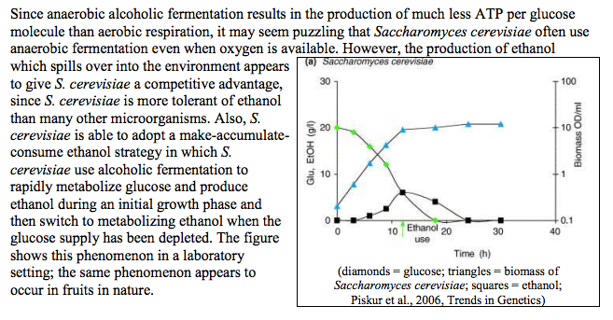

DATA TABLE | 0 min | 5 min | 10 min | 15 min | 20 min | 25 min
Test Tube 1
Yeast + Sugar + Water
Test Tube 2
Yeast + Sugar + Water
Test Tube 3
Yeast + Water
Test Tube 4
Yeast + Water

DATA TABLE | 0 min | 5 min | 10 min | 15 min | 20 min | 25 min
Test Tube 1
Yeast + Sugar + Water
Test Tube 2
Yeast + Sugar + Water
Test Tube 3
Yeast + Water
Test Tube 4
Yeast + Water
DATA TABLE | 0 min | 5 min | 10 min | 15 min | 20 min | 25 min
Test Tube 1
Yeast + Sugar + Water
Test Tube 2
Yeast + Sugar + Water
Test Tube 3
Yeast + Water
Test Tube 4
Yeast + Water

DATA TABLE | 0 min | 5 min | 10 min | 15 min | 20 min | 25 min
Test Tube 1
Yeast + Sugar + Water
Test Tube 2
Yeast + Sugar + Water
Test Tube 3
Yeast + Water
Test Tube 4
Yeast + Water

Materials:

Test tubes (4)
Test tube rack
Dry yeast (4 g)
Water
Sugar packet (1 tsp)
Balloons (4)
Sharpie
Procedure:
*Before you start you need to have a sketch in your notebook of what your experimental set up will look like. This will need to be approved by your instructor before you begin the experiment.
- Set up four test tubes in a test tube rack.
- Label each tube with a number, 1-4. Test tubes 1 and 2 will both have yeast with sugar and water. Test tubes 3-4 will both have only yeast and water, with no sugar.

- Fill Test Tube 1 with 4/5 full of warm tap water. Ask your instructor to add the yeast to Test Tube 1. Mix by putting your hand or thumb over the top of the test tube and rocking back and forth gently.
- Pour the yeast solution into the remaining test tubes so that each has an equal amount of yeast solution.
- Add a half packet (1/2 tsp) of sugar to Test Tube 1 and the other half packet of sugar to Test Tube 2. These tubes will be your experimental group. Do not add sugar to Tubes 3 and 4.
- Add warm tap water to each test tube, filling each tube 4/5 of the way to the top.
- Cover the opening of each test tube with a balloon to catch any gas that is formed. Using the balloon to seal the end of the test tubes, hold a finger over the end of each test tube and shake vigorously to thoroughly mix the contents.
- Observe the test tubes and record your observations carefully in the data table. Then, every 5 minutes for 25 minutes, observe what occurs in the test tubes (such as bubbles) and any changes in the balloons which cover each test tube, and record your observations.
- If the yeast grains are capable of metabolism, it will take time to produce enough carbon dioxide to see the change in the balloons.

