MACROMOLECULES QUIZ
For each of the monomers below you will identify the name of each monomer, name the type of macromolecule made from said monomer, describe the function of that type of macromolecule, and give an example of a molecule that belongs to that category.
MONOMER | MACROMOLECULE | FUNCTION | EXAMPLE
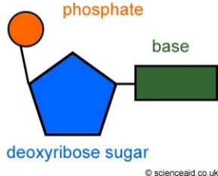
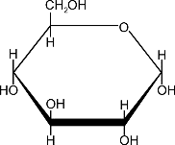

MACROMOLECULES QUIZ
For each of the monomers below you will identify the name of each monomer, name the type of macromolecule made from said monomer, describe the function of that type of macromolecule, and give an example of a molecule that belongs to that category.
MONOMER | MACROMOLECULE | FUNCTION | EXAMPLE

