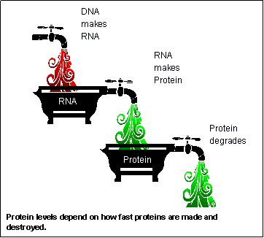
Name_________________________________________________ Period _________________
Making Sentences of DNA
Proteins go to work!
Introduction: The instructions coded in DNA must be read and turned into protein molecules for the cell to carry out the instructions. In this activity you will model this process using sentences for DNA and RNA and words for amino acids. The words must line up in the correct order for the protein to form properly, just like words in a sentence must line up. Good luck!
Instructions:
1. Go to the nucleus and find your DNA strands. Students must write down the DNA template card number, and write down the sequence of the DNA where it says DNA strand in the table.
2. With the DNA sequences you must now transcribe the DNA into mRNA (the message).
3. You will now translate the message by translating the mRNA to find the correct amino acids you will look for in the cytoplasm (lab area).
4. You write the words in the sentence area and when you get done you should have sentences.
DNA STRND
mRNA Copy
Sentence
DNA STRND
mRNA Copy
Sentence
DNA STRND
mRNA Copy
Sentence

Data 2:
1- Choose any of the DNA strands that you have above. Copy the DNA strand letters into the table below exactly as you did in the procedure above except that you need change the sequence to reflect the type of mutation indicated in each box.
2- Now go through the rest of the step by making mRNA, etc.
MUTANT SEQ (frameshift mutation)
mRNA Copy
Sentence
MUTANT SEQ (silent mutation)
mRNA Copy
Sentence
3- Explain how and why the new sentence is different.

4- What is it called when letters get either inserted or deleted from DNA?

Analysis:
5. In this activity you are working with words and sentences. The words and sentences represent other things in this process. Explain what the following represent in protein synthesis:
Words:
Sentences:
6. In this activity you made sentences that were coherent when you spoke them. Explain why having certain words in the order you had them was important to the function of the sentence.

7. Explain why it is wrong to say that “after the DNA is transcribed into mRNA it is then turned into tRNA”.

8. Name what special group of proteins make all of the reactions happen in this protein process. (They build and break things down and start with E)
9. Describe the role of:
DNA
mRNA
rRNA (Otherwise known as a Ribosome)
tRNA
10. Now put it together. Tell me the function of the following cell parts in the process.
Nucleus/DNA:
Ribosome:

