Name:__________________________________________________________ Date:___________________ Period:_____
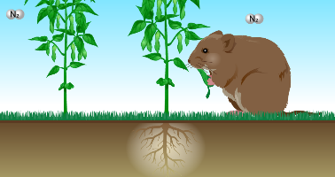
THE NITROGEN CYCLE
Directions: Log in to Blackboard and use the link “The Nitrogen Cycle Simulation” to access the simulation. Follow the instructions on the worksheet and the screen to complete this activity.
CLICK “GO”
- Plants and animals can use pure nitrogen gas (N₂): True or False? ______________

- When nitrogen is “fixed” it means that it is in what kind of form?

CLICK “NEXT”
- What is one way that N₂ can be fixed?

- After N₂ is fixed this way, what molecule does nitrogen become a part of? ____________
This molecule and other similar molecules are called “nitrates”.
CLICK “NEXT”
- How do plants obtain the fixed nitrogen from the atmosphere?

- What do plants do with nitrogen once they have it?
CLICK “NEXT”, READ THE INFORMATION, THEN CLICK “NEXT” AGAIN
- After N₂ is absorbed by the soil, what is a second way that it can be fixed?

- What is an example of a plant with root nodules? __________________________
CLICK “NEXT”
- Besides root nodules, where else can N₂-fixing bacteria be found? ________________
CLICK “NEXT”
- Where can animals get nitrogen?
CLICK “NEXT”
- How are nitrogen compounds returned to the soil?

CLICK “NEXT”
- When nitrogen compounds are converted back to N₂ the process is called “denitrification”. How does denitrification happen?
- Use what you have learned about the nitrogen cycle to write the correct statement in each blank of the diagram below!

