Name:____________________________________________ Date:______________ Period:_____________
UN officials hold emergency meeting in Zimbabwe to address armyworm threat
By Agence France-Presse, adapted by Newsela staff
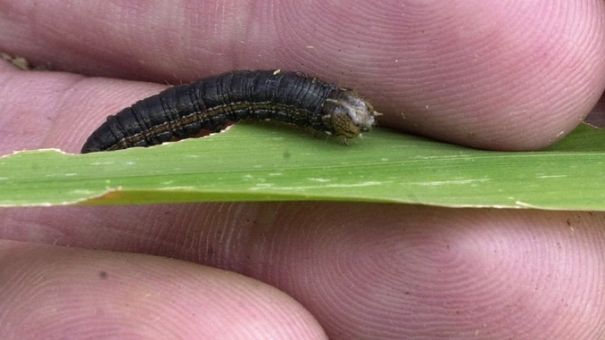
02.20.17
On Tuesday, international experts met for emergency United Nations talks in Harare, the capital of Zimbabwe. They warned that crop-eating armyworm caterpillars posed a serious threat to food supplies across several African countries.
The outbreak has already caused damage to staple crops in Zambia, Zimbabwe, South Africa and Ghana. Reports also suggest that Malawi, Mozambique and Namibia are affected.
Experts say it appears to be the first time that the "fall armyworm" species from the Americas has devastated crops in Africa. The first fall armyworms were seen in Nigeria and Togo last year. One theory says that they arrived in Africa on commercial flights from South America or in plants imported from the region.
The fall armyworm is actually the armyworm moth when it is in its larval stage, or early stage of life. The worm avoids the cold winters of North America by returning to a tropical habitat in the fall, hence its name “fall armyworm.”
Eating Key Food Sources
David Phiri, the U.N. Food and Agriculture Organisation (FAO) coordinator for southern Africa, told delegates that the armyworm posed "a huge threat to food security."
"We need to use our collective capacities to put up systems that will strengthen the resilience of our farmers," he said as talks opened.
Phiri says the pest appears to be moving into the region in a north to south direction.
The caterpillars eat maize, wheat, millet and rice. These are key food sources in southern and eastern Africa, where many areas are already struggling with shortages after years of severe drought.
Experts from 13 countries will spend three days in the Zimbabwean capital forming a battle plan to defeat the pests.
"Very Difficult To Control"
The armyworm is "spreading rapidly" in Africa and could even threaten farming worldwide, the Centre for Agriculture and Bioscience International (CABI) warned last week.
It said maize is particularly vulnerable to the larvae, which attack the crop's growing points and burrow into the cobs.
Unlike the native African armyworm, the fall armyworm does not "march" along the ground in huge numbers seeking more food, the FAO said.
The fall armyworm also attacks cotton, soybean, potato and tobacco fields.
Chemical pesticides can be effective, but fall armyworms have developed resistance in their native Americas.
"You use different methods. One of them is pesticides, another is to use biological control. Another is to use natural control, like digging trenches around the farm (or) natural predators, like birds," Phiri said before the meeting began.
"It's very difficult to control it, so they will have to use different methods — including sometimes burning the crops."

Another Hit To Africa's Farmers
Zimbabwe's deputy agriculture minister Davis Marapira confirmed to Agence France-Presse that the pest had been detected in all of the country's 10 provinces.
"The government is helping farmers with chemicals and spraying equipment," Marapira said.
The FAO, which is hosting the Harare meeting, said armyworm, combined with current locust problems "could be catastrophic." Southern Africa has yet to recover from droughts caused by the El Niño climate phenomenon.
In December, Zambia deployed its national air force to transport pesticides across the country so that fields could be sprayed.
"The fall armyworm has a potential to cause a serious food security problem in sub-Saharan Africa," Ken Wilson, an ecology professor at Lancaster University in Britain, told the meeting.
QUESTIONS:
- What is the main idea of this article?

- David Phiri, the U.N. Food and Agriculture Organisation (FAO) coordinator for southern Africa, called the armyworms “a huge threat to food security”. Is this characterization accurate? Give TWO evidences from the article that support your response AND include the paragraph it comes from.
*

*

- What steps can African farmers take to reduce the impact of fall armyworms on their crops?

- In paragraph 15, the article explains that some fall armyworms developed pesticide resistance in the Americas. Use your understanding of natural selection to explain how this resistance would have developed in American fall armyworm populations.

