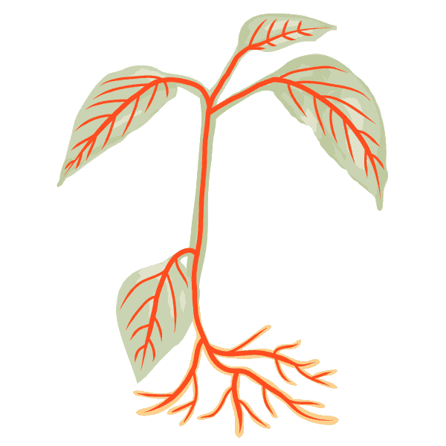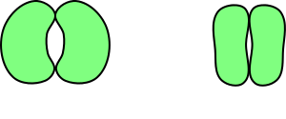

Label all of the structural adaptations on this plant and briefly explain the purpose of each

Use your understanding of osmosis and diffusion to explain how guard cells cause stomata to open and close.



Label all of the structural adaptations on this plant and briefly explain the purpose of each

Use your understanding of osmosis and diffusion to explain how guard cells cause stomata to open and close.