Name:________________________________ _________ Period:______ Date:_____________

RABBIT POPULATION GAME

Objective: You will create a population growth model for rabbits. The model will let you examine how density-dependent factors will affect the population size of rabbits.

PROCEDURE:
- On the field, two students will stand on one side and face the rest of the class about 30 meters away. The side with two students will represent rabbits and the other side will represent resources in the environment. Your teacher will stand on the sideline and will represent the decomposing area. See the figure below:
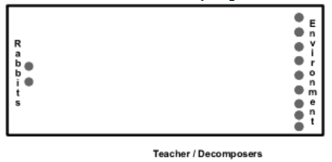

- At the beginning of each round (generation), the rabbits and environment need to face away from each other. Each member of the environment group will then choose the resource they want to be by either making a triangle over their head (shelter), putting a hand over their mouth (water), or putting a hand over their stomach (food).

- During this time the rabbits will individually decide which resource they will be searching for during the round.

- Once you have decided what you are searching for/what resource you will be you cannot change your mind!

- When your teacher says "Ready" the environment group will turn to face the rabbits while continuing to demonstrate which resource they are. When your teacher says "Set" the rabbits will turn to face the environment.

- When your teacher says "GO" the rabbits will run in a straight line toward the resource they are searching for. Rabbits cannot run around the environment area searching for their resource. When a rabbit has found a resource they will tag that person and stop running. Any rabbits who fail to tag a resource die and go to the decomposer section. This is the end of a round (generation).

- For the next generation, if a rabbit tagged a resource in the previous generation the rabbit survives and reproduces one offspring. The tagged environment person will become the new rabbit. Any decomposers will become an environment resource after one generation, however if a resource is not tagged they stay where they are for the next generation.

- Before your teacher starts the next generation with "Ready, Set, Go" the class will count the number of rabbits/environment people and your teacher will record the data.

- We will repeat this procedure for 8 generations.

- On the 9th generation a fox will be introduced to the ecosystem.

Hypothesis:
If a population of rabbits has no predators then the population growth will look like this:  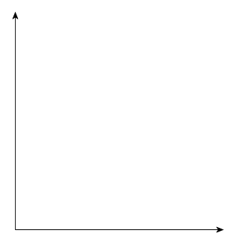  Generations | If a population of rabbits lives in an ecosystem with predators, then the population growth will look like this:  Generations

Data Table:
Generation | Rabbit Population | Environment Amount | Fox Population
1 | 2 |  | 0
2 |  |  | 0
3 |  |  | 0
4 |  |  | 0
5 |  |  | 0
6 |  |  | 0
7 |  |  | 0
8 |  |  | 0
9 |  |  | 1
10
11
12
13
14
15
16

Data Analysis:
- Plot all three sets of data from the game on the graph paper below. Use triangles to represent the environment amount, circles to represent the rabbit population and squares to represent the fox population. Connect the plot points for each set of data. Label each axis.
- How does this graph compare to the predictions you made earlier?

  - If your predictions were different from the actual results explain why this is the case:

- Every ecosystem can only provide for the survival of so many individuals in any population. At some point, resources or food become scarce and individuals begin to die off. The maximum number of individuals an ecosystem can support is called its carrying capacity.

  - What is this ecosystem's carrying capacity for rabbits?

  - What is this ecosystem's carrying capacity for foxes?

  - What factor affected the carrying capacity of the ecosystem in our game?

- What other factors limited rapid population growth in the ecosystem? These are called limiting factors (pretty obvious, I know). Think of at least TWO.

- What happened to rabbits that did not tag their corresponding resources?

- Why did a tagged resource become a rabbit in the next generation?

- Why did the dead rabbits not return to the environment in the very next generation?

