The History of DNA
Even though DNA has been known since the mid 1800’s, its structure and function weren’t discovered until the beginning of the 20th century. Our understanding of what DNA does and what it looked like took a long time to come together, but there were three key experiments that helped scientists learn what DNA does. Those experiments have been summarized for you here. Use the information in the passages and your own critical thinking skills to answer the following questions.

Griffith’s Experiment - 1928
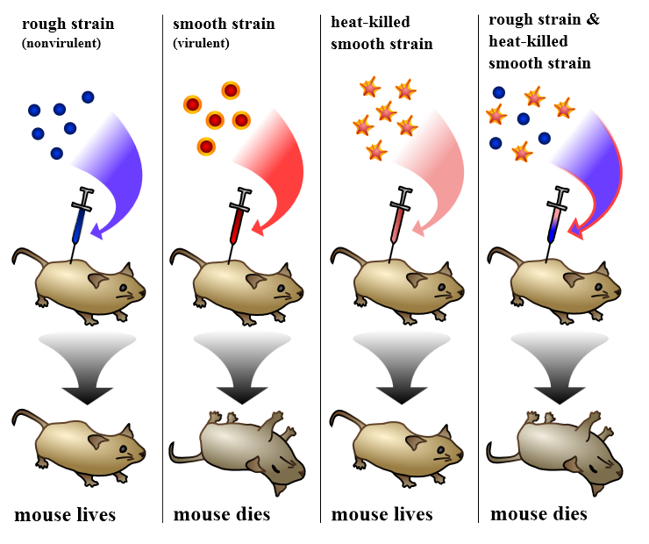
Frederick Griffith wanted to explore the differences between different types of pneumococcus bacteria (a bacteria that causes pneumonia). He did this by injecting mice with two different strains of bacteria. One, the rough strain, doesn’t cause disease. The other, the smooth strain, causes the mice to die. He also noticed that when the smooth strain was heated and then injected, the mice lived. But he also noticed that when both the heated smooth strain and the normal rough strain were both injected into the same mouse, the mouse died. The figure below summarizes the findings of his experiment.
1. What is the independent variable in Griffith’s experiment? What is the dependent variable?

2. Why did Griffith need to show that the heat-killed bacteria didn’t make the mouse die?

3. Why do you think that the mix of bacteria killed the fourth mouse?

Griffith’s Conclusion
Because the heat-killed bacteria mixed with the rough bacteria were lethal to the mouse, Griffith concluded that something from the heat-killed bacteria “transformed” the rough bacteria and made them lethal. But at this time, he had no idea what had caused the transformation. Other scientists picked up where he left off and tried to figure out what was causing the transformation. The first group of scientists to try were Oswald Avery, Colin MacLeod, and Maclyn McCarty.
Avery, MacLeod, and McCarty killed the bacteria in the same way as Griffith, and they then purified the different parts of the bacteria. They showed that when they injected the DNA portion of the bacteria into the mice, the mice died just as they did in Griffith’s experiments. This was the first evidence that DNA was the genetic material.
Hershey and Chase – 1952
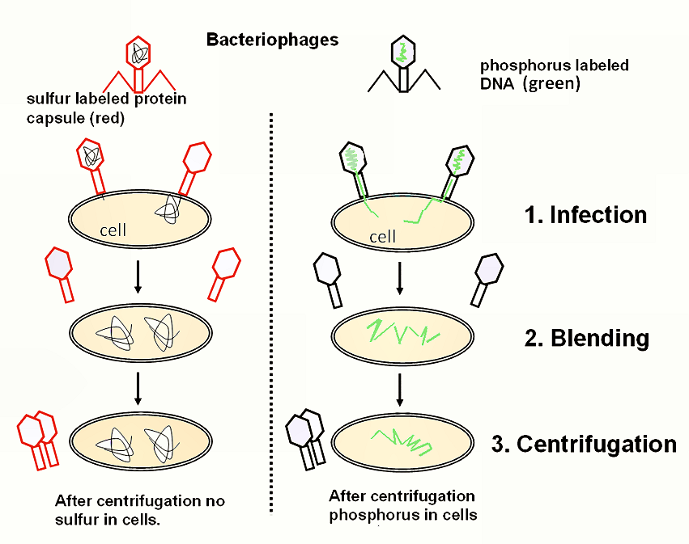
Alfred Hershey and Martha Chase took Avery’s experiment even further. They wanted to confirm what Avery and his colleagues found, so they studied the effects of a virus called a bacteriophage on bacteria cells. At the time, many people thought that proteins carried genetic information, so they put radioactive elements on both the proteins and the DNA of the virus. After the virus attached itself to the bacteria, they checked to see if the cell was radioactive. Their results are summarized in the figure below to the left.

4. Based on Hershey and Chase’s results, how was the virus infecting the bacteria?

5. Based on the results, do you think that DNA or proteins carry genetic information?

