Name: ______________________________________ Date: ________________________

Student Exploration: Translation

Vocabulary: Define these terms as you work on the Gizmo.
- amino acid
- anticodon
- codon
- gene
- ribosome
- transfer RNA
- translation
To begin this worksheet, you will need to re-create the mRNA strand based on the DNA template. Then click “Continue” to begin Translation.

Activity B:  Translation | Get the Gizmo ready:  - Once the mRNA strand has been built, click Continue. | 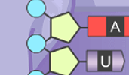

Introduction: After a strand of mRNA has been built, the strand exits the cell’s nucleus. The second stage of protein synthesis, called translation, occurs next. During translation, the strand of mRNA is used to build a chain of amino acids.

Question: What occurs during translation?

- Observe: Examine the strand of mRNA on the SIMULATION pane. Every group of three bases of mRNA is called a codon.

In the table at right, list the nitrogen bases in each codon. (Hint: Start from the top of the strand and read down.) The first mRNA codon is called the universal start codon.
Codon | mRNA bases
1
2
3
4

- Predict: Translation starts when a ribosome (the purple structure on the SIMULATION pane) binds to a strand of mRNA. Transfer RNA, or tRNA, begins bringing amino acids into the ribosome. Each tRNA molecule carries only one kind of amino acid. This amino acid is determined by the tRNA’s anticodon, a set of three unpaired bases.

Which anticodon do you think would attach to the mRNA’s start codon? ________________

Use the Gizmo to check your answer.

- Observe: Place the next two tRNA molecules on the mRNA strand. What happens?

_________________________________________________________________________

_________________________________________________________________________

As each tRNA molecule binds to the mRNA, the ribosome joins the amino acid carried by the tRNA to the growing amino acid chain.

- Describe: UAG (as well as UAA and UGA) is an example of a stop codon. Molecules called release factors bind to stop codons. Place the release factor on the mRNA molecule.

What happens? ____________________________________________________________

_________________________________________________________________________

Click Continue. Your protein is now complete. Most actual proteins consist of sequences of hundreds of amino acids.

- Infer: Why do you think stop and start codon signals are necessary for protein synthesis?

_________________________________________________________________________

_________________________________________________________________________

_________________________________________________________________________

- Summarize: Describe the processes of transcription and translation in your own words, based on what you have observed in the Gizmo.

Transcription: ______________________________________________________________

_________________________________________________________________________

_________________________________________________________________________

_________________________________________________________________________

_________________________________________________________________________

_________________________________________________________________________

Translation: _______________________________________________________________

_________________________________________________________________________

_________________________________________________________________________

_________________________________________________________________________

_________________________________________________________________________

_________________________________________________________________________

Extension:  Genes and traits | Get the Gizmo ready:  - You will not need to use the Gizmo for this activity. | 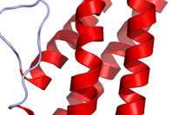

Introduction: Inside a ribosome, amino acids are linked together to form a protein molecule. As the chain of amino acids grows, it folds and coils to form a three-dimensional shape. The complex shape that results determines the properties of the protein. Proteins have a wide variety of structures and perform many essential functions in living things.

A sequence of DNA that codes for a specific protein is called a gene. By coding for proteins, genes determine an organism’s inherited traits.

Question: How do genes code for specific proteins and traits?

- Translate: Each codon codes for one of 20 amino acids. This code is universal among all living things. For example, the mRNA codon GGU codes for the amino acid glycine in every living thing, from bacteria to an elephant.

Examine the codon chart below. The amino acid coded for by a specific mRNA codon can be determined by finding the first base of the codon along the left side of the table, the second base along the top of the table, and the third base along the right side of the table.
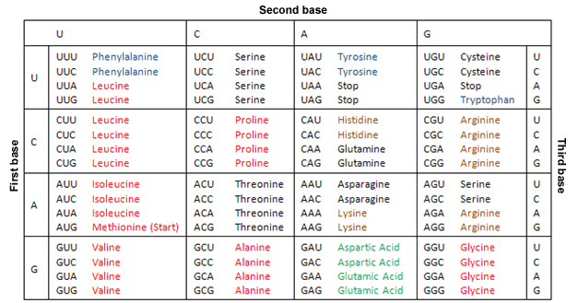

_________________________________________________________________________

What amino acids do the following codons code for?

AUG: _____________ CUG: _____________ ACC: _____________ UAG: _____________

- Apply: Suppose you wanted a protein that consists of the amino acid sequence methionine, asparagine, valine, and histidine. Give an mRNA sequence that would code for this protein.

___ ___ ___ ___ ___ ___ ___ ___ ___ ___ ___ ___

- Summarize: How do genes determine the traits of an organism? Explain in detail.

_________________________________________________________________________

_________________________________________________________________________

_________________________________________________________________________

_________________________________________________________________________

_________________________________________________________________________

- Extend your thinking: Sometimes errors occur during transcription or translation. Examine the codon chart on the previous page. Notice that each amino acid is coded for by several different codons. For example, alanine is coded for by GCU, GCC, GCA, and GCG.

How might this offset transcription or translation errors? ____________________________

_________________________________________________________________________

_________________________________________________________________________

